Rationale:

In line with Circular 0054/2022 – Exemptions from the Study of Irish, we have composed a policy to reflect the guidelines within our school context.

**Implications of an Exemption from the Study of Irish (now and into the future)**

**(*Reference: dyslexia.ie*)**

**Key Points to Note**

Irish is a compulsory or core subject throughout primary and secondary school. It is important to note that some students with dyslexia can successfully study Irish and other languages. However, for those with more severe dyslexia, learning more than one language at the same time can present huge difficulties and can lead to significant stress and anxiety. An exemption is essentially a form of reasonable adjustment for dyslexic students who are facing very significant challenges with literacy, and where other supports haven’t been sufficient to address their needs.

It is important to note that a pupil is not allowed to be exempt from the study of Irish simply because he or she is dyslexic, or because they find the subject difficult. There are very specific criteria that must be met in order to secure an exemption from the study of Irish – these are explained below in more detail.

Once the exemption has been granted it follows the student right through the school system and on to third level, where appropriate.

**Eligibility Criteria**

A child must be in at least Second Class at primary level with evidence that they meet the following eligibility criteria:

* significant and persistent learning difficulties must be present (this can be evidenced by the school as a formal diagnosis of dyslexia is not essential)
* extra teaching support has been put in place, namely a differentiated approach to language and literacy learning (but the guidance does not specify for how long).
* and despite this support, the young person must still be scoring at a low level in core literacy skills. This is evidenced by a score on a test of either Word Reading, Reading Comprehension or Spelling at or below the 10th percentile. This can be tested by the school.

The relevant Department Circulars for both primary and post-primary are available at <https://www.gov.ie/en/service/irish-exemption/>

If a dyslexic child does not meet the criteria for an Irish exemption on the grounds of Learning Difficulty, the newly added **Multiple and Persistent Needs category** might be an option, especially for pupils who have co-occurring learning difficulties impacting on mental health and anxiety. For this category, the pupil must be in at least Second Class and experiencing a high level of multiple and persistent needs. These needs must be persistent despite targeted and individualised support, as documented in Student Support Plans, over not less than two years. These needs must be a significant barrier to the pupil’s participation and engagement in their learning and school life and the pupil must have been given every reasonable opportunity to participate in the learning of Irish in mainstream classes for as long as possible. For pupils who meet these criteria, and if the Principal is satisfied that the granting of an exemption is in the overall best interests of the pupil concerned, an exemption from Irish can be granted.

**Application Process**

To apply, parents or guardians must make a written application to the school. You can attach supplementary documentation to support your application, this could be a letter or diagnostic reports if you have them, but this is not essential.

The outcome of the application must be confirmed in writing by the school within 21 school days of receipt of the application, and the Principal’s decision must be guided by the Circulars and the eligibility criteria.

If the exemption is granted, this should be confirmed to you in writing and a formal certificate of exemption provided by the school. This is an important document needed when transferring to post-primary, or third level, to evidence the exemption.

If the application is not granted, the school must explain in writing the reason why it has not been granted. If you are unhappy with this decision you can appeal. You have 30 days from the day you get the letter from the school saying ‘no’. There is an official form to make an appeal (one for primary and a different one for post-primary) available on the Department’s website at <https://www.gov.ie/en/service/irish-exemption/> where you will find all the guidance documents, forms and eligibility criteria.

**Next Steps to Consider**

Schools are used to having children who are not studying Irish (for a variety of reasons) and they are required to make arrangements for this. Ideally, if a child is getting additional teaching support this could be timetabled while the rest of the class is doing Irish. If this is not an option, the teacher should make arrangements for the child to do other work while the rest of the class is doing Irish, for example working on a computer, or working on their English literacy. Children are encouraged also to engage in the less formal aspects of the Irish lesson, such as drama, role play, songs and games.

Parents will explore the model for post-primary school with their chosen school.

**It is important to note that if a young person has an exemption this does not mean that they’re automatically exempt from a modern foreign language in post-primary school.** Only Irish and English are compulsory languages and it is not compulsory to do a third language. It is a school decision whether students study modern foreign languages, so therefore **there is no formal exemption procedure like there is with Irish**. Instead, it is a discussion and agreement with the school. Some schools will encourage students to try a foreign language for at least a term or for First Year, and then decide on whether it is appropriate to continue the language after that time.

**Implications for Third Level and Careers**

The National University of Ireland (NUI) requires Irish and a modern language in order to matriculate. However, the NUI will recognise the school exemption certificate, and extend this exemption in terms of any modern language matriculation requirements. You do need to apply to the NUI to have this recognised. See their website for details <https://www.nui.ie/college/entry-requirements.asp>

Be aware that some courses will require Irish or other languages because they are central parts of the course, for example, a European Studies or Business course may require a modern European language as a mandatory subject as it is a mandatory component of the degree course. In such cases, it is obviously not possible to get an exemption. However, for many such courses, there exists a comparable course, in the same college or in another college, which offers the same core degree without the language component.

**In terms of careers, there’s a very limited impact of not studying Irish up to the Leaving Certificate. The main career impacted is primary teacher training.** A higher pass in Irish is required for primary teacher training in Ireland. Some students circumvent this requirement by training as a teacher in the UK, and then completing an accredited conversion course in the Irish language. Or teach in only secondary schools or specialised settings.

**To pass the Bar exam to become a practicing solicitor, there is a requirement to pass a basic specified examination in the Irish language, and there are a few specific roles in the civil service where having Irish is an essential requirement, though most civil service roles do not require Irish. It is also worth noting that Irish is no longer required for entry to An Garda Síochána, following changes in 2022, where proficiency is now required in only one language**.

__________________________________________________________________________________

**I have been fully informed of the implications of being granted an Irish Exemption for my child and have been given a copy of this document by the Castletown school team.**

**Signed:____________________________________________________________________**

**Date:______________________________________________________________________**

***Scoil Ghormáin Naofa, Castletown*** 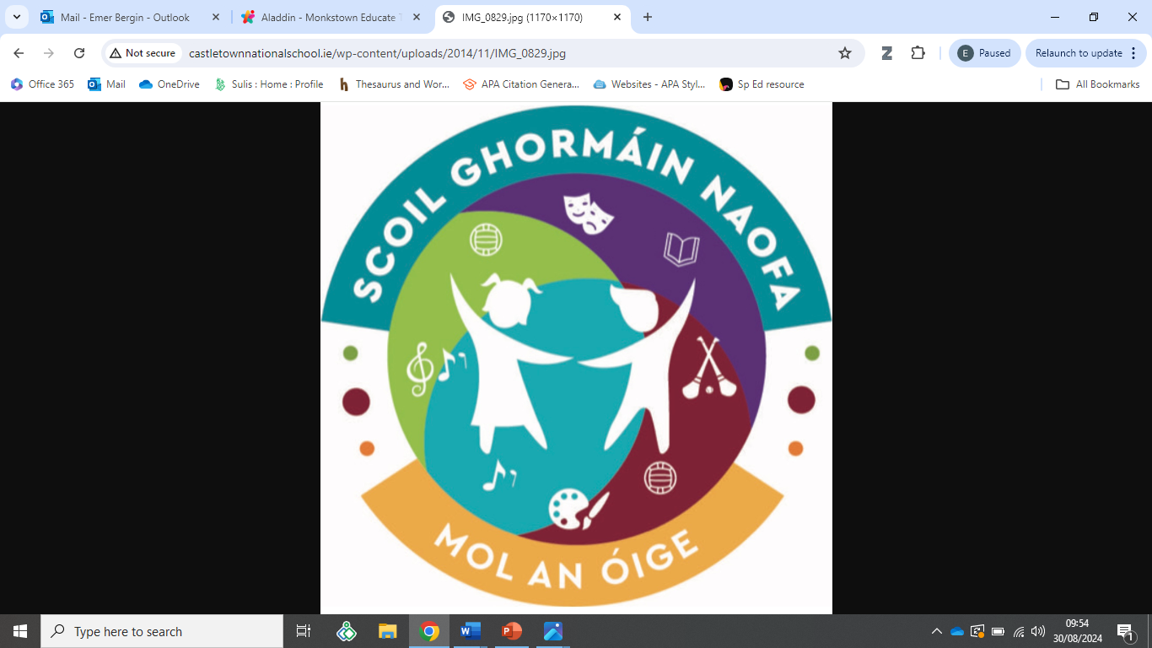

Dear Parent(s)/Guardian(s),

On the ______ of _________ 2024, we received your application for an Exemption from the

Study of Irish on behalf of __________________________ in accordance with Circular

0054/2022.

This application will be processed within 21 school days of receipt and we will be in touch

with regard to the outcome.

Kind regards,

_______________________ & ________________________

Emer Russell Louise Whittle

Principal SEN Coordinator