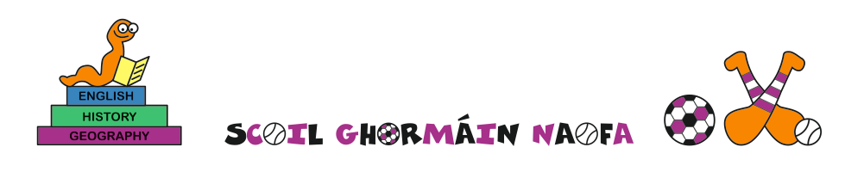
Admissions to the 2023/2024 academic year

A copy of the school’s Admission Policy for the 2023/2024 school year is available as follows:-
To download at: www.castletownnationalschool.ie
On request: By emailing secretarycastletownns@gmail.com
Or writing to: Scoil Ghormáin Naofa, Castletown, Gorey, Co. Wexford, Y25 DY05
Admission/enrolment forms available from the office at the above email address.

Part 1 Admissions to the 2023-2024 School Year
The school will commence accepting applications for admission on | 27th November 2023
The school shall cease accepting applications for admission on | 11th December 2023 at 15.00
The date by which applicants will be notified of the decision on their application is | 22nd December 2023
The period within which applicants must confirm acceptance of an offer of admission is | 2 weeks

*Failure to accept an offer within the prescribed period above may result in the offer being withdrawn

Note: the school will consider and issue decisions on late applications in accordance with the school’s admission policy.

Special Class Application and Decision Dates for admission to 2023/2024
The following are the dates applicable for admission to the school’s Special Class which caters for children with ASD –
The school will commence accepting applications for admission to the special class on | n/a
The school shall cease accepting applications for admission to the special class on | n/a
The date by which applicants will be notified of the decision on their application for admission to the special class is | n/a
The period within which applicants must confirm acceptance of an offer of admission is | n/a

*Failure to accept an offer within the prescribed period above may result in the offer being withdrawn

The number of places being made available in junior infants is | 27
The number of places being made available in the special class* catering for children with ASD is | 0

