Special Education Policy

Introduction
This policy on Special Educational Needs (SEN) provision was developed in February 2023 following consultation between school Principal, Assistant Principal II post holder and the Special Education Team. The policy was then circulated to other relevant stakeholders for feedback.

This policy reflects the new SEN allocation model and is in accordance with circular 0013/2017.

School Profile
Scoil Ghormáin Naofa is a co-educational school catering for children from Junior Infants to 6th class. The school is under the patronage of the Catholic Archdiocese of Dublin. Scoil Ghormáin Naofa currently has 6 Mainstream Class Teachers, 72.5 hours Special Education Teaching, 1 Special Class Teaching Post and 5.16 hours SNA allocation- shared between mainstream classes and special class (Academic Year 2022/2023).

Ethos

There is a spirit of inclusion in our school. We are proud to have a special class for children with ASD in our school and integration, appropriate to each pupil’s ability, is regular and meaningful. The school promotes inclusive dialogue, activities and practices with regard to pupils with SEN. The Code of Behaviour underpins the values of respect for one another and each other’s needs. Mainstream pupils are taught respect and understanding during SPHE and through the culture of the school. Whole school assemblies amongst other activities ensures the whole school gathering as a cohesive community with a diverse range of needs. Celebration of all pupils’ achievements is central to our belief system.

Overview
The purpose of this policy is to:
- provide practical guidance to staff, parents and other interested parties about our SEN procedures and practices
- outline the framework for addressing additional needs in our school
- fulfil DES circular 0013/17 – Circular to the Management Authorities of all Mainstream Primary Schools; Special Education Teaching Allocation, and 2017 document Guidelines for Primary Schools: Supporting Pupils with Special Educational Needs in Mainstream Schools
- fulfil scheme of grants towards the purchase of assistive technology, circular 0010/2013.

Scoil Ghormáin Naofa sets out to provide education for all its students, in line with legislation regarding students with SEN as listed below:
- The Education Act (1998)
- The Education Welfare Act (2000)
- The Education of Persons with Special Educational Needs Act (2004)

This policy is drafted in the context of:
- DES publication: Guidelines for Primary Schools: Supporting Pupils with Special Educational Needs in Mainstream Schools
- DES Circular 0013/17- Circular to the Management Authorities of all Mainstream Primary Schools
- DES Circular 0030/2014
- National Educational Psychological Service (NEPS) document: Special Educational Needs: A Continuum of Support.

Aims of Special Educational Needs Provision

For the Child
- To enable each child to reach his/her potential with a view to achieving adequate levels of proficiency in Literacy and Numeracy.
- To enable each child to experience success.
- To enable each child to participate as fully as possible in the curriculum for his/her class level.
- To develop the self-esteem of each child.
- To enable children to monitor their own learning and to contribute to their own learning targets.
- To help the child to develop self-management skills.
- To provide supplementary teaching where needed.

For Parents
- To consult parents at each stage of the Continuum of Support.
- To involve parents in the formulation of Student Support Plans.
- To assist parents in learning support activities in the home.
- To keep parents informed of assessment procedures and results of tests.
- To involve parents in the implementation of Early Intervention Programmes.

As Teachers
- To use a wide range of strategies to support children with special educational needs.
- To ensure that all the necessary resources are in place to assist children with special educational needs.
- To initiate Early Intervention Programmes.
- To collaborate with relevant parties in the implementation of a programme of additional support when it is needed.
- To consult with other professionals such as Psychologists, Psychiatrists, Speech and Language Therapists and Occupational Therapists etc. where necessary.

Roles

Role of Board of Management
- To oversee the development, implementation and review of the Special Education Policy.
- To ensure that adequate classroom accommodation and teaching resources are provided for the Special Education Team.
- To provide a secure facility for storage of records relating to pupils attending the Special Education Teachers.

Role of Principal
- To monitor the development and implementation of the school policy on Special Education.
- To meet with the Special Education Teachers at least twice a year to discuss the progression of the special educational needs of the school.
- To oversee the implementation of the Assessment Policy.
- To keep teachers informed about external assessment services and procedures to be followed in initiating referrals.
- To liaise with the Board of Management in relation to developments in Special Education.
- To liaise with external agencies such as NEPS to arrange assessments and provision for pupils with Special Educational Needs.
- To liaise with the SENO (Special Educational Needs Organiser) in relation to the allocation of additional Special Educational Assistants (SNAs).
- To submit applications and supporting evidence for the above.
- To compile SNA timetables based on allocation granted by the S.E.N.O.
- To communicate with outside professionals such as Speech & Language Therapists, Occupational Therapists, Educational Psychologists etc.
- To communicate with outside agencies such as Child and Adolescent Mental Health Services (CAMHS), Assessment of Need Officer etc.
- To help teachers to increase their knowledge and skills in the areas of special education teaching and in class support by providing advice with regard to teaching methods and encouraging them to avail of relevant training.
- To arrange for classroom accommodation and resources as appropriate.
- To liaise with the appropriate school personnel in relation to NEPS assessments and to ensure that appropriate paperwork is completed prior to each assessment.
- To obtain the required number of quotations and to submit the necessary application in conjunction with the supporting reports for Assistive Technology, based on the recommendations of outside professionals.
- To apply for grants and ensure purchase of equipment.
- To liaise with the Special Educational Needs Organiser (S.E.N.O.) in relation to the allocation of additional Special Educational Teaching hours.
- To submit the appropriate supporting documentation for the above
- To ensure that all relevant requirements are complied with in relation to retention of data.
- To liaise with relevant Post Primary schools to aid with the transition of S.E.N. pupils to Second Level (to send the necessary paperwork, reports, etc. and to organise for the pupils to visit the school) with consent of parents / guardians.

Role of Assistant Principal II Post
Administrative
- To attend ISL meetings as part of the post of responsibility, at agreed date and time after school, to co-ordinate the implementation of curricular content and administrative policies.
- To complete a report of the post for the attention of the Board of Management.
- To liaise with the Principal to formulate, implement and review the Special Education Policy for the school.
- To liaise with the Principal to formulate, implement and review the Assessment and Recording Policy for the school.
- To read, review and ensure the proper filing of children’s assessments/reports.
Organisational
- To catalogue/audit and maintain special equipment for SEN pupils, testing manuals and equipment in SET.
Pastoral
- To co-ordinate the teaching of Special Education for the whole school.
- To co-ordinate the implementation of structured team-teaching programmes once per year/per class.
- To liaise with SET, Class Teachers, Language Support Teachers, parents, SNAs and outside agencies in relation to SEN.
- To oversee the documentation with regard to SEN; Support Plans, Assessment Reports, school assessment results, and ensure they are kept up to date, filed safely/correctly and made available to those who need them.
- To assist the integration of new pupils, foreign pupils and pupils with additional needs.
- To be responsible for the timetabling of SNAs, SET teachers and the special class teacher.
- To report to staff at meetings regarding new interventions or supports available, training days or updates in SEN.
Curricular
- To support staff in the development of School Support Plans.
- To liaise with outside agencies, parents, SEN team & Principal and update all on new initiatives where relevant.
- To gather and compile data relevant to SEN teaching- individual pupil results, class results to inform in-class support.
- To review/update the SEN section of the school's curricular policies.
- To co-ordinate the administration of the Belfield Infant Assessments in Junior Infants.
- To co-ordinate the administration of the Middle Infant Screening Test in Senior Infants.
- To co-ordinate the administration of the New Non-Reading Intelligence Test in 2nd Class.
- To co-ordinate the administration of the Drumcondra Reading and Maths from 1st to 6th
- To co-ordinate the administration of the Triail Ghaeilge Dhroim Conrach do Bhunscoileanna Rialta i Rang a 3 agus Rang a 5.
- To analyse the results of these and to decide on necessary intervention.
- To liaise with Class Teachers to ensure the Continuum of Support is fully implemented across the Classes to support all pupils with emerging needs.
- To advise Class Teachers to ensure that appropriate differentiation is put in place for such pupils, that parents / guardians are consulted and that all actions are recorded (“Classroom Support Level”.).
- To subsequently liaise with the Principal in deciding if further intervention is necessary and if the pupil will be supported at the “School Support Level” / “School Support Plus Level”.
- To communicate with outside professionals such as Speech & Language Therapists, Occupational Therapists, Educational Psychologists etc.
- To advise and support staff in relation to supporting pupils with Special Educational Needs.
- To ensure the completion of the appropriate documentation by Class Teachers and Special Education Teachers at all levels of the Continuum of Support.
- To review the school’s Special Educational Needs Policy and Assessment and Recording Policy at regular intervals.
- To review the school’s Special Educational Needs strategies at regular intervals.
- To collate a list of all pupils at the different levels of the Continuum of Support for the whole school.
- To identify the pupils with English as Additional Language (E.A.L.) needs and to include these pupils in the SEN timetables.
- To ensure the effective implementation of class-based interventions such as Ready, Set, Go Maths, etc. and follow-up interventions, where necessary.

Role of Class Teacher
- To maintain primary responsibility for the children with additional educational needs in his/her class.
- To differentiate the class curriculum appropriately to meet the needs of all the pupils in the class, in particular to implement teaching programmes which optimise learning in the classroom e.g. grouping children and providing lower achieving children with strategies for reading and problem solving.
- To collaborate with the Special Education Teacher in relation to the administration of Standardised Tests.
- To employ the Continuum of Support in relation to a child experiencing difficulties.
- To ensure the Student Support File is opened as necessary and a Classroom Support Plan is agreed. To review and update plans regularly. To communicate their concerns and plans with the parents.
- To liaise closely with parents and the Special Education Teacher in relation to the planning and implementation of in class support plans and the formulation of Student Support Plans.
- To ensure records are kept of children following a programme of additional support.

Role of Special Education Teachers
- To liaise with APII post holder with the administration of screening and standardised tests.
- To consult with the Class Teachers with regards to the identification of children who may need additional support.
- To carry out assessments of pupils who have been identified as low achieving and / or having learning difficulties, when necessary.
- To devise and implement a programme of work for those children who have been selected for additional support.
- To facilitate the formulation of a School Support Plan/School Support Plus Plan for those children selected for supplementary teaching and to monitor and review the attainment targets set out in the support plan of each child.
- To maintain a weekly or fortnightly planning/progress record for children receiving support and to submit a Cuntas Míosúil to the Principal.
- To provide advice to Class Teachers on strategies and materials to enhance learning in the classroom and to work with them in the classroom in a shared teaching approach where necessary.
- To meet with parents regularly, minimum twice a year, accompanied by the Class Teacher as necessary. Planning meetings take place in October and February accompanied by phone calls as appropriate.
- To meet with the Principal at least twice a year to discuss issues relating to special education and to give an overview of each child receiving supplementary teaching.
- To meet with other relevant professionals, in the children’s interest e.g. Psychologist, Speech and Language Therapists etc.
- To attend training and attend meetings with relevant agencies such as NEPS, NCSE, etc. The SET should keep up to date with new developments in special education and international best practice.

Role of Parents
- To provide a home environment which fosters opportunities for children to participate in Language, Literacy and Numeracy activities in their early years.
- To support the work of the school by participating with their children in early intervention programmes such as shared reading.
- To implement the suggested home based activities as outlined in the SSP in the case of children who are receiving supplementary teaching.
- To inform the school of any learning difficulties they observe in their children at home.
- To provide the school with relevant reports and assessments as well as recommendations from the outside agencies/healthcare professionals their child may access to.

Role of Pupils (as appropriate)
- To become familiar with the targets set and to contribute to them where feasible.
- To contribute to the selection of texts and other learning materials relevant to the attainment of these targets.
- To apply the learning strategies and skills taught to them to improve their own learning.
- To participate in appropriate assessment activities.

Special Needs Assistants
Special Needs Assistants (SNAs) are recruited to provide support in assisting children with special educational needs, who also have additional and significant care needs. SNA access is granted to pupils by the SENO, who also decides the number of SNAs the school is allocated to assist with these care needs. The deployment of SNAs within the school is at the discretion of the Principal. Timetables and duties are assigned by the Principal acting on behalf of the Board of Management.
- There is a stand-alone SNA policy in place.

Duties
The primary duties of a SNA are related to the primary care needs of pupils with Special Educational Needs. However, their duties also include:

- Special assistance, as necessary, for children with particular difficulties e.g. helping pupils with additional needs with clothing, feeding, toileting and general hygiene where necessary, as well as with typing / writing/ IT or other equipment.
- Engagement with the parents of children with additional needs in both formal and informal structures as required and directed by school management.
- Supervision of children with the Class Teacher during assembly and play times.
- Preparation of materials and provision of general assistance to the Class Teacher.
- Accompanying individuals or small groups who may have to be withdrawn temporarily from the classroom to another part of the school and providing assistance with out-of-school visits, walks etc.
- Provision and supervision of movement/sensory breaks as needed or quiet time.
- Participation in School Development planning where appropriate and co-operation with any changes to policies and practices arising from the school development process.

Special Needs Assistants timetables may be altered throughout the school year, as needs within the school change, or when urgent demands arise. SNAs reflections and input are highly valued with regard to this.

Personal Pupil Plan
Each child who has been granted SNA access must have an accompanying Personal Pupil Plan (PPP). This plan is drawn up by the SENCo in collaboration with Class Teacher and SNA. The plan will outline the care needs of the child and how the SNA will be deployed to assist the pupil. The PPP will include time-bound targets for the development of independence skills. The SNA will assist in monitoring the implementation and impact of the plan.

Early Intervention, Prevention & Class Based Support
The following programmes are implemented as part of our policy to enhance learning and prevent and reduce difficulties for our children.
- Phonological Awareness programme- Junior Infants
- Shared Reading- Junior & Senior Infants. (This involves children taking books home, reading them to their parents)
- Ready, Set, Go Maths- Junior Infants & Senior Infants (for part of the year)
- Aistear- Junior & Senior Infants
- Paired Reading- parents/grandparents read with the pupils from Juniors to 4th
- Maths for Fun- Senior Infants & 2nd Class (will start in Term 3)
- In Class Support is utilised in Scoil Ghormáin Naofa to address the needs of our pupils. Although there is a focus on supporting pupils on the Continuum of Support, all pupils benefit from the varying Co-Teaching models.
- Class Teachers and Special Education Teachers collaborate on the planning and preparation for in class support and decide on the model of co-teaching that will best support the needs of the class.
- The school uses the following models of in class support;
One Teach, One Observe Alternative Teaching
One Teach, One Assist Station Teaching
Parallel Teaching Team Teaching

Curriculum Differentiation
As stated previously Scoil Ghormáin Naofa is committed to ensuring that every child, regardless of their special educational needs, is entitled to access the entire curriculum as fully as possible. The responsibility is on us to differentiate the curriculum to ensure that this is a realistic objective.

To ensure inclusion, we differentiate the curriculum in terms of:

Environment
- The learning environment can be mobile i.e. it can change from the classroom to the hall, yard, field or other venues as appropriate.
- The classroom can be organized to accommodate a variety of work stations.
- Classroom resources such as Interactive Whiteboards, iPads (& specific apps) and the Internet are utilized to make the learning environment as stimulating as possible.
- The atmosphere in the Classroom can change from one of lively debate, discussion and physical activity to one of quiet thought and reflection.

Content
- The content is integrated as much as possible to enable children to see links between different themes and subjects.
- Reading materials at varying levels of readability are used.
- The content focus begins with self, family and friends, the wider community and extends to the world at large.
- The amount of content presented is geared towards the ability of the child and the child tackles the content at his / her own pace.

Process
- Content is presented through visual, auditory, tactile and kinaesthetic means taking into account the learning style of the child.
- Tiered activities are used so that all children can study the same topic but proceed with different levels of challenge.
- Concrete materials and hands-on experience are used wherever possible.
- Pair and Group work approaches such as ‘Think, Pair, Share’ are used to encourage cooperative learning.
- Active exploration and discovery learning is vital irrespective of the child’s level of ability.
- The pace of learning can be varied as some children move at different rates from low level thinking to higher levels.

Outcome
- The amount of work produced may vary from child to child.
- A variety of different methods may be used to demonstrate learning e.g. written work, art work and project work.
- Work may be presented orally, in handwritten form or typewritten form depending on the special educational needs of the child and all are equally valid and valued.
- Various audiences can be used when demonstrating the product: Principal, Parents and / or other children.

Assessment
Assessment provides us with information on a child’s achievements and difficulties and helps us to plan future learning i.e. our assessment is of learning and for learning. The progress of each child is monitored by the Class Teacher and the Special Education Teachers. Assessment OF Learning and Assessment FOR Learning are in operation in the school.

Assessment is carried out through:
- Teacher Observation / Teacher designed tasks and tests
- Checklists / Rating Scales
- Time-Sampling Recording / Event Recording
- Portfolios / Projects
- Standardised Testing / Screening Testing

Note: All methods of Assessment are of equal value. See also Scoil Ghormáin Naofa’s Assessment Policy.

Testing
Tests are carried out in all classes on a regular basis.

Screening Tests: The following tests are used to screen in Scoil Ghormáin Naofa:
- Pre-School Profile- Mo Scéal (NCSE)-Junior Infants, on enrolment.
- Belfield Infant Assessment Profile (BIAP)-Junior Infants, February.
- Middle Infant Screening Test (MIST)- Senior Infants, February.
- New Non Reading Intelligence Test (NNRIT)- 2nd class, February.
- Examples of other screening tests that are used at the discretion of the school can be found in Scoil Ghormáin Naofa’s Assessment and Recording Policy.

Standardised tests: The following are carried out annually in May;
- Drumcondra Primary Reading Test-1st-6th classes, May.
- Drumcondra Primary Maths Test-1st-6th classes, May.
- Triail Ghaeilge Dhroim Conrach do Bhunscoileanna Rialta- Ranganna 3 agus 5, May.

Test Procedure
Detailed information on the standardised testing procedure can be found in Scoil Ghormáin Naofa’s Assessment and Recording Policy.

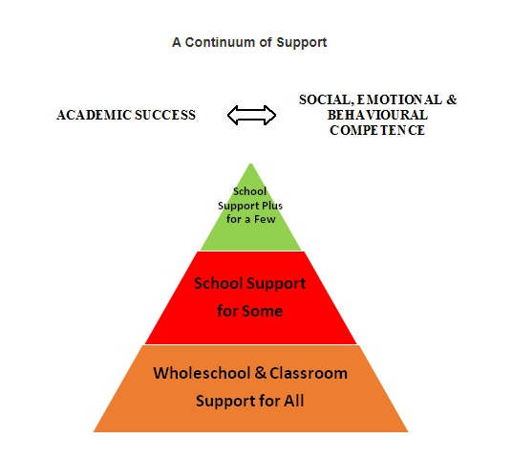

Continuum of Support

According to the NCSE;

The Department has set out the Continuum of
Support framework to assist schools in identifying
and responding to students’ needs. This framework
recognises that special educational needs occur
along a continuum, ranging from mild to severe,
and from transient to long term, and that students
require different levels of support depending on
their identified educational needs. Using this framework
helps to ensure that interventions are incremental, moving
from class-based interventions to more intensive and individualised support, and that they are informed by careful monitoring of progress.

The Continuum of Support enables schools to identify and respond to needs in a flexible way. This means that needs can be responded to as early as possible. Of course, the principle that pupils with the greatest level of need have access to the greatest levels of support is of primary importance. This approach is also supported by information and engagement with external professionals, as required.

When deciding whether a student requires support, relevant school staff may use the below flow charts to decide on the level of support required. (NEPS Resource: A Continuum of Support: Guidelines for Teachers).

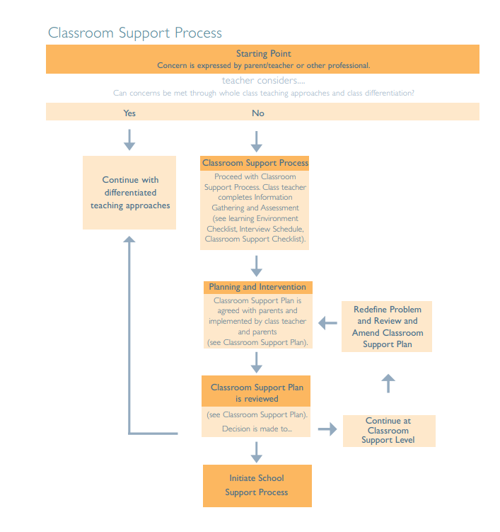
Stage One: Classroom Support

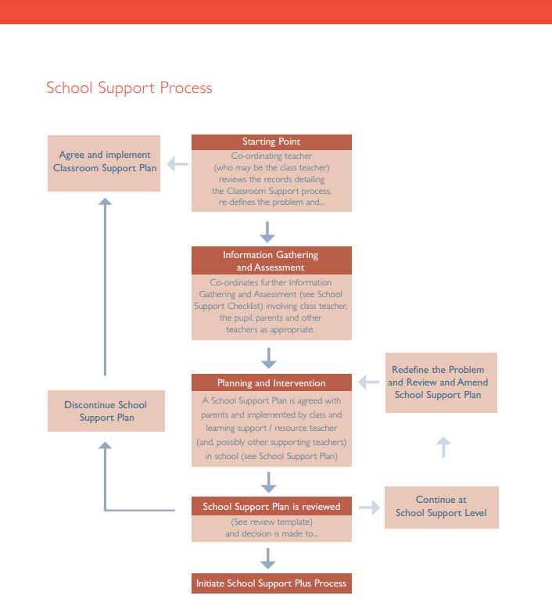
Stage Two: School Support

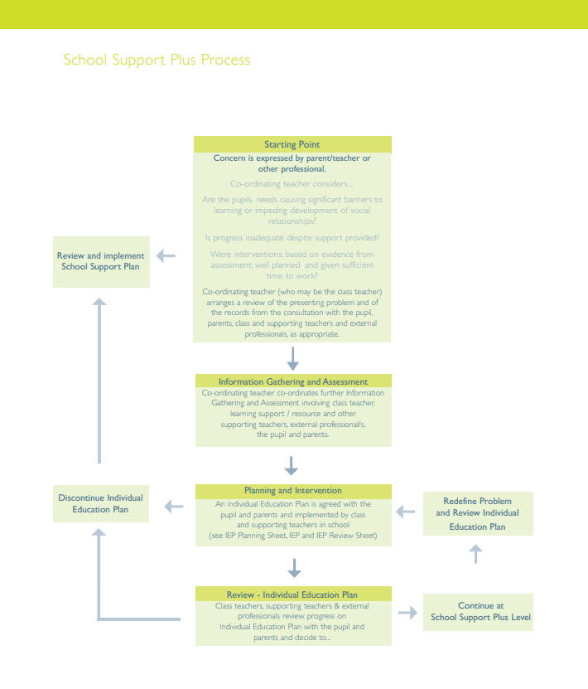
Stage Three: School Support Plus

Stage One: Classroom Support Level
- A child is identified as having difficulty in one or several of the following areas following Assessment by the Class Teacher:
- Physical Development
- Social and Emotional Development
- Behavioural Development
- Speech and Language
- Numeracy / Literacy
*This list is not exhaustive.
- The Class Teacher meets with the parents to discuss the area(s) of concern.
- A differentiated approach is discussed and class supports are put in place for the child.
- The Class Teacher draws up a short Classroom Support Plan (recorded on Aladdin) in consultation with the Parents to be implemented in the classroom for a period of 6 to 8 weeks. Where necessary the Special Education Teacher may also be consulted.
- The success of this classroom support plan is reviewed at the end of this period and if there is ongoing concern or the desired outcome has not been reached, intervention may continue to Stage Two.
- If there is serious concern in relation to the other areas assessed, intervention also proceeds to School Support. In extreme cases it may be necessary to begin the Psychological Assessment Procedure at this stage.

Stage Two: School Support Level
- Further assessments may be considered at this stage.
- If testing suggests that a literacy / numeracy support programme involving the Special Education Teacher would be beneficial then this is put in place immediately.
- The Special Education Teacher (SET), Class Teacher and Parents will agree targets for the child’s School Support Plan. The School Support Plan is signed by teachers and parents and a review date is agreed.
- Once the School Support Plan has commenced subsequent meetings are arranged every October and February to discuss the child’s progress. In cases where the support programme is to be continued, revised learning targets and activities are set.
- Following the review meeting it may be appropriate to scale back the level of support. The child may be supported in class at classroom support level and the child’s progress monitored and reviewed regularly.
- At the discontinuation of the School Support Plan a meeting is held with parents where advice is given about methods and materials which will ensure progress is maintained.

Note: See also the Special Education Teaching Allocation Model below.

Stage Three: School Support Plus Level
- Having provided in class support and differentiation by Class Teacher and having undertaken a School Support Plan with SET there may be a need to move a child to stage 3 of the Continuum of Support; School Support Plus.
- School Support Plus refers to support for few. In other words, those children that have the greatest level of need and those children who require further assessment and intervention.
- At this stage a Psychological Assessment or Multi-Disciplinary Assessment may be recommended.
- Parental consent is sought before initiating the Assessment Procedure (See Referral for Assessment below).
- Following the results of the assessment, advice is sought from the Psychologist and/or other professionals such as Speech and Language Therapists, Occupational Therapists etc.
- A School Support Plus Plan is then drawn up following consultation with Parents, Class Teacher and Special Education Teacher.
- The Special Education Teacher (SET), Class Teacher and Parents will agree targets for the child’s support plan. The School Support Plus Plan is signed by teachers and parents and a review date is agreed.
- Once the School Support Plus Plan has commenced subsequent meetings are arranged every October and February to discuss the child’s progress.
- Continued collaboration with the relevant agencies e.g. NEPs, SENO, NCSE etc. continues throughout.

The Special Education Teaching Allocation Model
This new model, outlined in Circular 0013/2017 by the Department of Education, combines the previous models: The general allocation model & low-incident teaching hours.
The school’s allocation is calculated by the National Council of Special Education using the following information:
- Baseline (the number of children enrolled)
- Complex Needs (current NCSE Low Incidence Resource Teacher allocations)
- Achievement Data held by the DES (Standardised Tests)
- Social Context including disadvantage
- Gender

This model provides additional teaching resources (teachers) to assist Scoil Ghormáin Naofa in making appropriate provision for its pupils. As per Circular 0013/2017, the school must consider the following when identifying pupils for support;

- Standardised tests can be used to screen and identify pupils’ performance in reading and mathematics. Those pupils performing below a Standard Score of 95 should be prioritised for support in literacy and numeracy.
- Pupils who were previously in receipt of supplementary teaching from a resource or learning support teacher and who continue to experience significant learning difficulties.
- Pupils who are identified as having significant needs through a process of ongoing assessment and intervention as set out in the Continuum of Support Process (DES, 2010). This will be evidenced through school-based assessment of attainment, and behavioural, social and emotional functioning and ongoing monitoring of learning outcomes. Schools should also take into account needs set out in professional reports, where available.
- Pupils with mild or transient educational needs including those associated with speech and language difficulties, social or emotional problems, or co-ordination or attention control difficulties.
- Pupils who have specific learning disabilities.
- Pupils with significant Special Educational Needs. For example, pupils with significant learning, behavioural, emotional, physical and sensory needs.
- Schools should also carefully consider the needs of other pupils who may present with a range of learning needs, whose interaction may present a significant barrier to the pupils’ learning and ability to access the curriculum.
- Pupils who have additional literacy or language learning needs including those pupils who need English as an Additional Language Support.

The intensity of additional support that is provided for pupils with low achievement and pupils with special educational needs should be based on their needs and should be provided differentially through the continuum of support process.

Most of the pupils described above will receive additional teaching support in the classroom or in small withdrawal groups in addition to the support they receive from the class teacher. However, some pupils may also require intensive additional one to one teaching support for a specific period of time.

Special Education Planning
In planning to meet the additional special educational needs of pupils, schools should plan in a manner consistent with the size of the school, the learning profile of the pupils with special educational needs, and the expertise of the school staff. As stated in Circular 24/03, the overriding principle is that resources should be deployed in Scoil Ghormáin Naofa, in the manner that best meets the needs of the pupils with special educational needs in the school in a given year.

The following factors will also be considered in order to achieve this:
- Interventions with pupils should be delivered in a manner that best meets the needs identified, which may be through group or individual teaching.
- The development of literacy and numeracy skills will be a major component of many interventions at stages II and III. However, special educational needs in areas such as oral language, social interaction, behaviour and emotional regulation skills and application to learning tasks may also need to be addressed.
- The following is a general outline of a general approach used in Scoil Ghormáin Naofa when planning for the deployment of resources each given school year:
- Identify those pupils not accessing the curriculum.
- In class intervention/support plan put in place for 6 to 8 weeks.
- Class teacher will review progress or otherwise.
- Child may be monitored or moved to Stage 2.
- Those children at stages 2 and 3 will receive supplementary teaching and support from the Special Education Teacher (SET). The support and progress will be reviewed.
- Children may return to stage 1 following a period of support at stage 2. These children will be monitored to ensure progress is maintained.
- Children working at stages 2 and 3 may receive a combination of one to one or small group support. This will be decided by the Principal in collaboration with the Special Education Teacher and Class Teacher and in accordance with the resources available to the school as well as the level of need of the child.
- Recording and active tracking of pupils is essential to planning.
- Principal and SET team will meet regularly (at least twice a year) to discuss the caseloads of each SET. Further meetings will take place in June to plan for SET in the coming school year.
- Principal will liaise with the SENO and NEPs regularly in order to ensure a suitable level of support and resources are available to the pupils and staff of Scoil Ghormáin Naofa.

Individual Support Plans
School Support Plans and School Support Plus Plans are formulated twice yearly for all pupils receiving supplementary teaching. The Support Plans are formulated in conjunction with the Class Teacher, Special Education Teacher, parents and in some cases other Educational Professionals.
A School Support Plan and School Support Plus Plan will contain:
- Details of age, class, names of Class Teacher and Special Education Teacher.
- Date on which the child began the support programme.
- Results of Standardised and Diagnostic Tests (where relevant).
- Relevant information relating to a child’s learning attainments.
- Information about his/her learning strengths.
- Information about his/her learning needs.
- Targets for medium term planning which will be brief, specific and measurable.
- Strategies and resources which will be used to implement those targets.
- The school has its own template for Support Plans.

Referral for Psychological Assessment
A psychological assessment may be recommended in order to provide us with:
- Additional information about a child’s difficulties.
- Advice about teaching strategies and resources.
- Assistance in applying for other support e.g. Special Needs Assistants or Assistive Technology.

A psychological assessment is recommended where:
- The results of testing carried out by the Special Education Teacher warrant further assessment and a Special Education Condition, Learning Disability or specific Learning Difficulty is suspected.
- Having initiated a School Support Plan with a child and little progress is taking place.
- There appears to be a marked discrepancy between perceived ability and performance.
- There are several emotional and /or behavioural problems.

Provision of Psychological Assessment
- Psychological assessments may be done privately or done through the school.
- The school is assigned a school psychologist through NEPS scheme (National Educational Psychological Service). Our current school psychologist is Aoife O’Connor (NEPS).
- In the event of our Educational Psychologist not being available (e.g. maternity leave) the school then has access to psychological assessments through the Scheme for Commissioning Psychological Assessments SCPA, which is administered by NEPS. The number of educational assessments provided under this scheme is at the discretion of NEPS.
- Priority is given to younger children (generally observations will take place in Junior/ Senior Infants and referrals made in 1st/2nd Class)and children in Fifth/Sixth Class who may be leaving the school with undiagnosed learning disabilities.
- Parents may choose to arrange an assessment privately through a private Educational Psychologist or other agency. The school has a list of psychologists from a national database-https://www.psychologicalsociety.ie/. Scoil Ghormáin Naofa can share the contact details, however, the school does not endorse or promote any one psychologist over another.

Procedure for Psychological Assessment
- Having worked through the levels of support the Class Teacher may, in consultation with the Special Education Teacher, recommend an assessment.
- Parental consent is sought for the assessment.
- When consent is obtained a decision is made about the provision of the assessment.
- Where the assessment is to be carried out with NEPS Psychologist, the Principal contacts NEPS to arrange for a school visit. Consent forms / referral forms are completed with parents in advance. The NEPS Psychologist will meet with staff and/or parents, before observing the pupil and carrying out the assessment, when appropriate. A report is issued to the school following the visit(s).
- Where the assessment is to be carried out through SCPA, the Principal contacts an Educational Psychologist and a date for the assessment is arranged. Consent / Referral forms are completed by parents & school. The Assessment takes place in the school. After the Assessment, the Psychologist meets with the Parents. The Psychologist meets with the Class Teacher and Special Education Teacher. A report is sent to the parents and to the school.

Parental Partnership in the Provision of Special Education
Every effort is made to ensure that parents are full and equal partners in the special education provided for their children. Teachers and parents working together create the conditions for every child to reach his or her potential. Effective communication is essential for this to take place.

We facilitate this by:
- Initiating Early Intervention Programmes.
- Providing guidelines on Reading Approaches, Spelling, Homework etc.
- Organising Parent/Teacher Meetings.
- Forwarding Parents an End of Year Report on their child’s progress.
- Facilitating meetings to initiate and review the SSP.
- Suggesting strategies for helping with their children’s Special Needs.
- Informing Parents of seminars held outside the school which are relevant to their child’s needs. Parents may talk to their child’s Class Teacher or Special Education Teacher at an appointed time at any stage during the year if they are anxious about their child’s progress.

Timetabling & Inclusion
Timetabling for special education support is done through a collaborative approach between the Special Education Teacher, Class teachers and Principal. Every effort is made to ensure that children are not removed from the same curricular area each day. Due recognition is taken of the specific needs of each child. The school is committed to the inclusion of all pupils in school activities. Therefore, extra support will be provided to pupils with special educational needs (through SNA or SET) during activities in which they require it. e.g. Off campus field trips, sporting activities etc.

Special Education Teacher’s – Individual Planning & Records

Long Term Planning
The primary long term plan for children in receipt of individual teaching is their School Support Plan or School Support Plus Plan.
- SSPs are private and confidential. Each child in receipt of individual teaching has an individual folder. SSPs, details of contact with professionals, assessments, professional reports, monthly targets, and observations (from SEN team, class teacher and SNA-when relevant) are kept locked in the child's individual folder in the central storage area & in the SET filing cabinet.
- SSP meetings take place twice yearly with parents (and any other relevant professional).
- Targets should be finalised by the end of each meeting.
- All test results and school based assessment documents must be uploaded to Aladdin.

- * Personal Pupil Profiles (for care needs) will be drawn up and a copy will be kept in the relevant pupil’s Support File and a copy will remain with the Class Teacher/SNA. PPPs are updated each September.

Short Term Planning
- Timetable – detailing children that are withdrawn / in-class support should be submitted to the Principal in the month of September.
- Detailed short-term planning (weekly/fortnightly) documents are to be kept by the SET. These plans may be for individual pupils, groups, or in-class support.
- Class Teachers must use the school’s template for Classroom Support Plan and Special Education Teachers must use the school’s templates for School Support/School Support Plus Plans.

Monthly Record
- Each SEN teacher must complete their Cuntas Míosúil monthly for all teaching whether 1 to 1, small group or in class initiatives.
- Cuntas Míosúil should be submitted at the end of the month.
- Support Plans should be reviewed, with targets updated as necessary. A full review of SSP should take place twice a year.

Implementation, Review and Communication
This new SEN policy was developed and adopted by the Board of Management in March 2023. The Board of Management will monitor the implementation of all aspects of this policy and amend as required. The policy will be reviewed in the light of experience. It will be reviewed fully every three years, or sooner if necessary. Any staff member, Board of Management member or parent / guardian of a current student, may request a review at any time, and such a request will be dealt with as soon as possible.

Next Review Date: March/April 2026

Signed:
(Principal)

Signed:
(Chairperson B.o.M)

Appendix: Identification of Needs through the Continuum of Support Process - (Primary Guidelines, p.9-10)
Classroom Support | The class teacher considers how to differentiate the learning programme effectively to accommodate the needs of all pupils in the class. A classroom support plan is developed and / or adjusted over time for those pupils who do not respond appropriately to the differentiated programme.  This is informed by:  ∙ Parental consultation  ∙ Teacher observation records  ∙ Teacher-designed measures /assessments  ∙ Basic needs checklist *  ∙ Learning environment checklist*  ∙ Pupil consultation - My Thoughts About School Checklist  ∙ Literacy and numeracy tests  ∙ Screening tests of language skills  A Classroom Support plan runs for an agreed period of time and is subject to review
School Support | At this level a Support Plan is devised and informed by:  ∙ Teacher observation records  ∙ Teacher-designed measures / assessments  ∙ Parent and pupil interviews  ∙ Learning environment checklist  ∙ Diagnostic assessments in literacy/numeracy  ∙ Formal observation of behaviour including ABC charts, frequency measures  ∙ Functional assessment as appropriate, including screening measure for social, emotional and behavioural difficulties  A support plan at this level may detail suitable teaching approaches including team-teaching, small group or individual tuition. A School Support Plan operates for an agreed period of time and is subject to review
School Support Plus | This level of the Continuum is informed by a detailed, systematic approach to information gathering and assessment using a broad range of formal and informal assessment tools, reports from outside professionals (as appropriate) and may include:  ∙ Teacher observation and teacher-designed measures  ∙ Parent and pupil interviews  ∙ Functional assessment  ∙ Results of standardised testing such as measures of cognitive ability; social, emotional and behavioural functioning; adaptive functioning etc.  Data generated from this process are then used to plan an appropriate intervention and can serve as a baseline against which to map progress. A support plan at this level is likely to be more detailed and individualised, and to include longer term planning and consultation
*These checklists are available in the Continuum of Support Guidelines for Teachers

