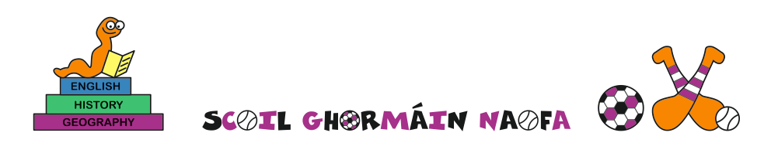
SCHOOL UNIFORM 2023-2024
Tracksuit
- Wine tracksuit (wine/grey shorts may be worn for summer and early autumn terms)
- White polo shirt (plain)
- Shoes: Any colour trainers may be worn, however on formal uniform days, children must wear black shoes/black runners so it is advisable to purchase black trainers to cover both formal and informal uniform days.
The school tracksuit is available online from https://schoolwearhouse.ie/product-category/castletown-ns/

Formal Uniform
Boys | Girls
Wine V-neck jumper/tracksuit top | Wine V-neck jumper/tracksuit top
Grey trousers/grey shorts | Grey skirt/pinafore/grey trousers/grey shorts
White shirt/white polo shirt | White shirt/white polo shirt
Black shoes/Black runners | Black shoes/black runners
Black socks/white socks | Black/White socks/tights
All the above can be purchased through high street stores. Formal jumper is available to purchase online but is not a necessary purchase.
Either uniform may be worn in school, with the exception of set PE days which will be advised by teacher in advance.
Formal uniform will be required for special events and occasions.
Please ensure that uniforms are fully labelled.
We wear our uniform to show pride in our school and ourselves and thank you for ensuring that children present themselves with care and cleanliness each day for school.

