Assessment and Recording Policy

Introduction
This policy was originally drafted in 2022 in order to give structure and focus to our existing assessment practices. It was further developed in 2023 following ratification of our Special Education Policy and consultation between school Principal and Special Education Team. The policy was then circulated to teaching staff for feedback.

Policy Rationale
The core of this policy is that all children should work to their individual potential and experience success at school. We endeavour to identify children who may have learning difficulties or exceptionally able* at the earliest possible opportunity, and put in place a programme to respond to their needs. The Policy was drafted with reference to the Assessment in the Primary School Curriculum- Guidelines for Schools publication.
*Additional support for exceptionally able pupils will be given if/when possible.

Relationship to School Ethos
The school adopts a holistic approach to the education and development of each child and the enhancement of teaching and learning processes. An effective Assessment Policy identifies early interventions that need to be put in place to ensure that each child reaches his/her potential and positive self-esteem is achieved.

Aims and Objectives
- To facilitate improved teaching and pupil learning
- To target needs and strengths
- To create a procedure for monitoring progress and achievement
- To compare and cross reference scores from all assessments in order to identify differences. To use this information to understand whether the child is performing to their personal ability and/or class ability and planning support to target gaps in learning where needed.
- To track learning processes which assist the long and short term planning of teachers
- To co-ordinate assessment procedures on a whole school basis, including storage of tests and results and reporting of same.
- To co-ordinate assessment procedures on a whole school basis, involving parents and pupils in managing strengths and weaknesses and providing support through the Continuum of Support and informal communications.

Principles
- Careful thought is given to the purpose of assessment, adopting a wide range of methods to reflect the whole Curriculum and learning opportunities. The main purpose of assessment must be to facilitate progress in pupils’ learning.
- Assessment is an integral part of the teaching and learning process, a valuable formative tool.
- The range of opportunities for carrying out continuous assessment is increased by good classroom organisation, which encourages children to work independently while the teacher is working with a small group.
- The outcomes of assessment modify our teaching methods, provide feedback on the Curriculum as well as indicate pupil progress.
- We recognise the potential for assessment in developing a positive self-image in the pupil from positive and constructive feedback and the feeling of success, which encourages further study.
- In addition to normal assessment, opportunities are taken to record significant points in a child’s development, such as;
- A moment of ‘breakthrough’ in understanding
- Surprises and unusual reactions
- Interesting strategies for mental calculation
- Difficulties encountered and possible reasons for them.
- Results of assessment are reported in a way useful for pupils, teachers, parents and other interested parties.
- Assessment records must be easy to interpret, useful, manageable and should not be administrative burdensome.
- Formal assessment is recorded on Aladdin.
- STens are shared with parents in end of year report with the exception of significant jumps or dips, which will be indicated to parents at time of their identification.

Assessment Techniques
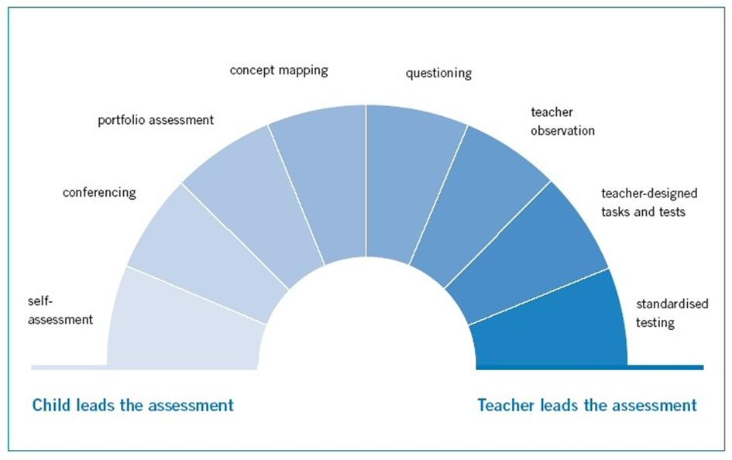
The teaching staff of Scoil Ghormáin Naofa will employ a variety of assessment techniques which will inform the future teaching of their pupils. The Continuum of Assessment Methods will be used to ensure Assessment FOR Learning and Assessment OF Learning is taking place.

Examples of Assessment Techniques used;
- Teacher Observation (focused, continuous, informed and structured)
- Teacher designed tasks and tests; weekly and termly tests, projects, reports and homework.
- Discussion / Conferencing
- Concept Mapping
- Checklists / Rating Scales
- Time-Sampling Recording / Event Recording
- Portfolios / Projects
- Screening tests
- Standardised testing
- Diagnostic testing- making reference to reports and recommendations where applicable

Cover will be provided for regularly scheduled conferencing meetings between Class Teachers and Special Education Teachers. These meetings will allow for collaboration on supporting individual pupil needs and whole class needs.

Continuum of Support
Assessment in Scoil Ghormáin Naofa supports all pupils in their learning and informs the implementation of all stages of the Continuum of Support. Assessment will inform relevant school staff on whether a pupil is performing to their ability or whether they will require further support. Once pupils have been identified as needing support, assessment techniques will be used to monitor improvement of the pupil’s specific targets.
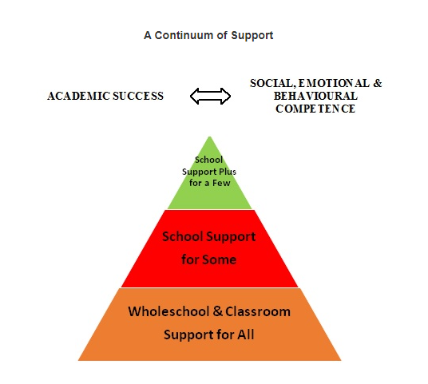

Curricular Assessment
Each subject area on the curriculum will be assessed by the individual teacher. Forms of assessment will reflect the purpose of the assessment; Assessment OF Learning and Assessment FOR Learning.

Screening Schedule
The following tests are used to screen in Scoil Ghormáin Naofa:
- Pre-School Profile- Mo Scéal (NCCA) document sent out in advance of starting school- Junior Infants, on enrolment.
- Belfield Infant Assessment Profile (BIAP)- Junior Infants, February.
- Middle Infant Screening Test (MIST)- Senior Infants, February.
- New Non Reading Intelligence Test (NNRIT)- 2nd class, February.
- Bangor Dyslexia Test- used to look for indicators of dyslexia but not as a diagnostic tool- when necessary
- NEPs Checklists
- NEPs “My Thoughts About School” assessment
- Dolch/High Frequency Words check list- periodically during Junior and Senior Infants
- Letter formation assessment list- periodically during Junior and Senior Infants
- Jolly Phonics sounds assessment list- periodically during Junior and Senior Infants
- CVC/decodable/nonsense words list- periodically during Junior and Senior Infants
*Testing schedule is subject to change as need arises.

Standardised Testing Schedule
The following standardised tests are used in Scoil Ghormáin Naofa:
- Drumcondra Primary Reading Test- 1st-6th classes, May.
- Drumcondra Primary Maths Test-1st-6th classes, May.
- Triail Ghaeilge Dhroim Conrach do Bhunscoileanna Rialta- Ranganna 3 agus 5, May.
*Testing schedule is subject to change as need arises.

Supporting Assessment across Educational Contexts

Preschool to Primary School
Scoil Ghormáin Naofa believe the observations of preschool practitioners and parents are key in supporting the introduction of children into Junior Infants and identifying needs in advance. This information allows the school to plan effectively.
Mo Scéal document (NCCA) is a collaborative document between preschool practitioners, parents and new pupils. It is used to elicit strengths and weaknesses in advance of children starting school.

Primary to Secondary School
Scoil Ghormáin Naofa believe in supporting the transition of our pupils into Secondary Level. Pupils and parents of 6th class pupils fill out My Education Passport (NCCA) and the school forwards these to relevant Secondary Schools. End of year reports, including STen scores are also forwarded.
Where relevant, and with the permission of parents, children with additional needs are facilitated in meeting a representative from their new Post Primary school to discuss a plan for their transition. They will be accompanied by their class teacher and/or school principal.

Standardised Testing Procedure

Administration and Correction
- Tests are administered and corrected by the Class Teacher.
- Corrected results are uploaded to the Aladdin system.

Exclusion from Tests
- Pupils may be excluded from the tests if in the view of the Principal, and in line with DES guidance, they have a learning, communicative or physical disability which would prevent them from attempting the test.
- Children may also be excluded if their level of English is such that attempting the test would be inappropriate.

Recording
- Test results will be recorded electronically (via the school data system Aladdin) by the Special Education Teacher. A class score sheet is generated and given to the class teacher.
- The Special Education Teacher will have access on Aladdin to the results of children they work with for the purpose of further testing and tracking of results.

Tracking
- Results of tests are tracked from year to year using percentile scores/STen and recorded on Aladdin.

Storage
- Test booklets are stored with the child’s personal file.
- Test results are stored digitally, using the school data system Aladdin.
- Results are kept as per Scoil Ghormáin Naofa’s Data Protection Privacy Statement – until the pupils have reached aged 26.

Reporting of Results
- Children are not given the results of tests.
- Results of standardised tests are reported to parents via the end of year School Report Card. Results are given in terms of STen Scores and are accompanied by the teacher’s overall comments on the pupil’s performance in those areas.
- Where a concern about a child’s tests results arises the Class Teacher will make contact with parents to discuss the concern (prior to June report).
- On identification of an exceptionally able student, recommendations for support will be made to parents, such as Centre for Talented Youth, reading challenges, etc.
- Where children are transferring to other Primary Schools or Secondary schools results may be forwarded to them without permission from parents. In this event STen scores are shared with the school and not percentile scores.
- The school will report aggregate standardised test results for 2nd, 4th and 6th Class (via EsiNet) once annually to the Department of Education.
- At the end of each year Class Teachers are given the opportunity to meet with the previous Class Teacher to discuss the results of the tests and the strengths and weaknesses of each child.

Test Analysis
- Test results will be analysed by the Class Teachers and the Special Education Teachers and used to both monitor the child’s progress and to inform classroom planning. (The results may also be used in the school’s self-evaluation process).

Note: Parents are not given copies of the test. The Class Teacher may show the completed test booklet to parents if requested, and if this is appropriate in individual circumstances. A parent may view their child’s booklet in the presence of the teacher. No photographs are permitted.

Recording & Storage of Assessments

Class Based Assessments/Test
- Each Class Teacher is responsible for the appropriate storage of class tests, portfolios, checklists and observations relevant to inform the teaching and learning within their class.
- Where appropriate a selection of these can be passed to next class teacher to help inform their knowledge and understanding of the incoming class.
- All other records are to be shredded at the end of the school year.

Standardised Test Results
- Test results will be stored electronically (via the school data system, Aladdin) by the Special Education Teacher.
- A class score sheet is generated and given to the class teacher. The Special Education Teacher will retain a copy for the purpose of further testing and tracking results.
- Test booklets are stored for 12 months in a secure filing cabinet, until replaced by the following year’s test. The test booklets are then shredded.
- Class Result sheets, along with school reports are kept as per Scoil Ghormáin Naofa’s Data Protection Privacy Statement -until the pupils have reached age 26, and then shredded.

Diagnostic/Psychological Assessments
- Results of any such testing are kept securely in the pupil’s individual file in the office.
- These assessments and accompanying recommendations are copied and attached to the child’s file in the Special Education Room.
- Copies of assessments and recommendations will be scanned to the child’s personal file on Aladdin. Staff access to pupil’s account will be given on a need to know basis.
- These are kept as per Scoil Ghormáin Naofa’s Data Protection Privacy Statement -until the pupils have reached age 26, and then shredded.

Implementation and Review
This Policy was adopted by the Board of Management in 2022 and reviewed in 2023.
The policy will be fully implemented by September 2023. The Board will monitor the implementation of this policy and amend as required.
The policy will be reviewed fully ever three years, or sooner if necessary, by means of a whole school collaborative process.

Next Review Date: March/April 2026

Signed:
(Principal)

Signed:
(Chairperson B.o.M)

References
Assessment in the Primary School Curriculum- Guidelines for Schools-NCCA
DES Circular 02/05
DES Circular 24/03
DES Learning Support Guidelines 2000
www.sess.ie
Working together to make a difference for children- NEPS

