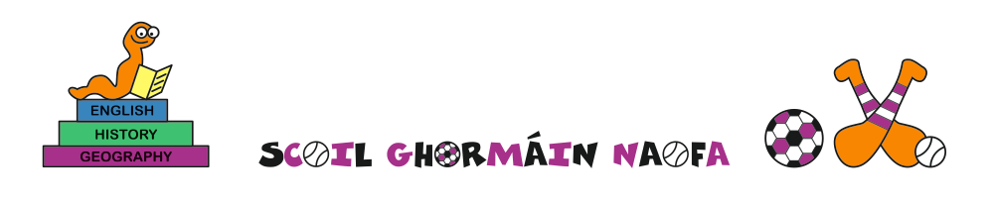School calendar 2023- 2024

School will reopen on Tuesday 29th August
- Junior infants will attend from 10-12 from Tues 29/09 to 01/09 inclusive
- Junior infants will attend from 9-12 for two weeks from 04/09 to 15/09, after which they will attend from 9-1.40 daily

Hallowe'en midterm closed from Monday 30th October to Friday 3rd November inclusive

Christmas: final day of term is Friday 22nd December, school will reopen on Monday 8th January 2024

New Bank Holiday Monday 5th February

Mid-term break: Thursday 15th and Friday 16th February

Bank Holiday: 17th March

Easter holidays: final day of term is Friday 22nd March 2024, school will reopen on Monday 8th April

Midterm break: closed from Monday 6th May to Friday 10th May inclusive

Bank holiday: Monday 3rd June

Last day of school – Wednesday 26th June

