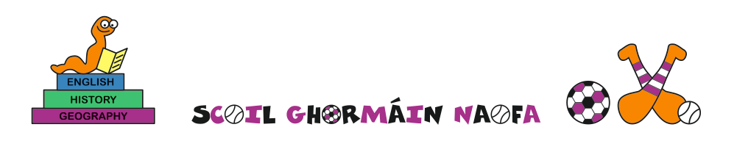
School calendar 2022-2023

School will reopen on Tuesday 30th August

Hallowe'en mid term closed from 31st October, reopening 7th November

Christmas: closed from 22nd December, reopening 5th January

New Bank Holiday on Monday 6th February

Mid-term break: 16th and 17th February

Bank Holiday: 17th March

Easter holidays: closed from 3rd April , reopening 17th April

Bank holiday: 1st May

Mid-term break: Closed from 5th June, reopening 12th June

Last day of school – Wednesday 28th June

