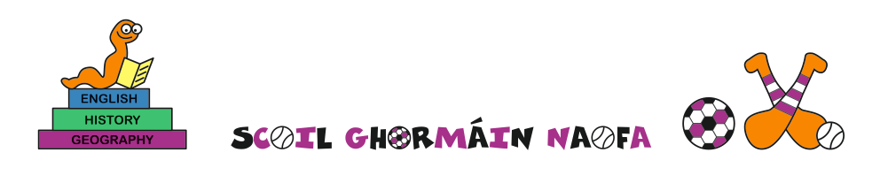

School Calendar 2021-2022

School will reopen on Tuesday 31st August

October 2021 mid-term break
School will close from Monday 25th October 2021 to Friday 29th October 2021 inclusive.

Christmas 2021
School will close on Wednesday 22nd December 2021 which will be the final day of the school term and will re-open on Thursday 6th January 2022

February 2022 mid-term break
School will close on Thursday 24th February and Friday 25th February 2022.

School will be closed on 17th , 18th and 21st March

Easter holidays: School will close on Friday 8th April 2022, which will be the final day of the school term and will re-open on Monday 25th April 2022

June Mid-term break: School will close (including bank holiday) from June 6th- 10th inclusive
School will close on June 30th

Scoil Ghormáin Naofa, Castletown, Gorey, Co. Wexford
Roll no. 17768k
Tel: 0402 37596
Email: secretarycastletownns@gmail.com

