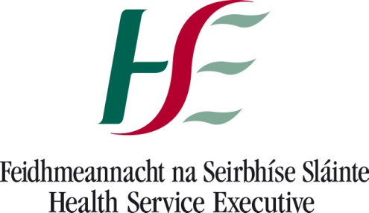 Monday 6 September 2021

Re: Confirmed case of COVID-19 at your child’s school.

Dear Parent/ Guardian,

A person has tested positive for COVID-19 in your child’s school. A public health risk assessment has been carried out.

Your child is not a close contact

What does your child need to do?
- Your child does not need to restrict their movements.
- Your child can go to school
- Your child does not need to be tested for COVID-19

What do household members need to do?
Household members, such as parents and siblings do not have to restrict their movements and can go to school/crèche/work/college etc.

If your child is well and has no COVID-19 symptoms, household members, such as parents and siblings do not have to restrict their movements and can go to school/crèche etc.

What if my child becomes unwell now or at any time in the future?
If your child becomes unwell with any of the following:

Temperature of 38 degrees Celsius or more New cough
Loss or changed sense of taste or smell Shortness of breath
Sore throat Headaches
Diarrhoea Vomiting
An existing breathing condition that has become worse

- Your child should be isolated immediately
- Phone your GP for further advice.
- If your GP refers your child for a Covid test (because of their symptoms), all household members including siblings should now also be kept at home and restrict their movements while awaiting the results of this test.

Public Health has advised the parents of all children deemed to be close contacts of the confirmed case. Thank you for following this advice. These actions help stop the spread of the virus.

Further information on COVID-19 is available at: www.hse.ie and www.hpsc.ie or you can phone HSELive at 1850 24 1850.

Yours faithfully,

_____________________
Dr. Sinéad Crowley MCRN 423342
Department of Public Health, HSE South East

