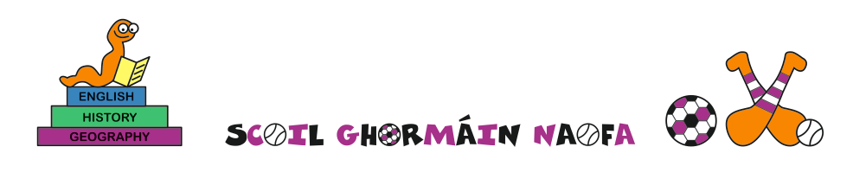

Agreed report – Board of Management meeting 19/03/2021

Present: Emer Russell, Joe O’ Shaughnessy, James Neville, Sínead Fanning, Mary Hearne, Seamus Kavanagh, Paula D’Arcy

- Minutes of last meeting proposed and seconded
- Child Protection Oversight report read and adopted
- E-payments for school businesses being applied for
- Children are settling back in happily and working very well
- Date of next meeting tbc

Scoil Ghormáin Naofa, Castletown, Gorey, Co. Wexford
Roll no. 17768k
Tel: 0402 37596
Email: secretarycastletownns@gmail.com

