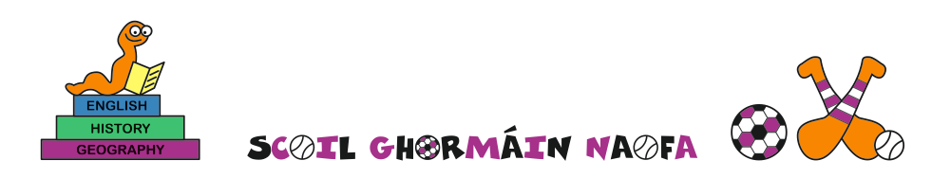
Admissions to the 2021/2022 academic year

A copy of the school’s Admission Policy for the 2021/2022 school year is available as follows:-
To download at: www.castletownnationalschool.ie
On request: By emailing secretarycastletownns@gmail.com
Or writing to: Scoil Ghormáin Naofa, Castletown, Gorey, Co. Wexford, Y25 DY05
Admission/enrolment forms available from the office at the above email address.

Part 1 Admissions to the 2020-2021 School Year
The school will commence accepting applications for admission on | 1st February 2021
The school shall cease accepting applications for admission on | 14th February 2021 at 15.00
The date by which applicants will be notified of the decision on their application is | 21st February 2021
The period within which applicants must confirm acceptance of an offer of admission is | 2 weeks

*Failure to accept an offer within the prescribed period above may result in the offer being withdrawn

Note: the school will consider and issue decisions on late applications in accordance with the school’s admission policy.

Special Class Application and Decision Dates for admission to 2021/2022
The following are the dates applicable for admission to the school’s Special Class which caters for children with ASD –
The school will commence accepting applications for admission to the special class on | 1st February 2021
The school shall cease accepting applications for admission to the special class on | 14th February 2021 at 15.00
The date by which applicants will be notified of the decision on their application for admission to the special class is | 21st February 2021
The period within which applicants must confirm acceptance of an offer of admission is | 2 weeks

*Failure to accept an offer within the prescribed period above may result in the offer being withdrawn
Number of places being made available in 2021/2022

The number of places being made available in junior infants is | 27
The number of places being made available in the special class* catering for children with ASD is | 4

