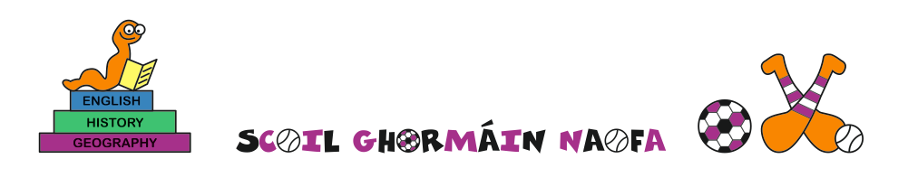
Sts Mary’s & Peter’s Arklow St Patrick’s Castletown St David’s Johnstown
23rd October 2020
1st HOLY COMMUNION PARENTS - COVID LEVEL 5

Dear Parents/Guardians
I wish to thank all who have returned their letter stating that your son/daughter has completed with you the nine-lesson Booklet “Preparing for 1st Holy Communion – a guide for families”. It is essential that your child understands the meaning of the Mass and Holy Communion, and is familiar with all the Mass responses in the final chapter of the booklet. I thank all the teachers in our schools who have helped the children by reinforcing what you have done with your child at home.
We had hoped to celebrate the 1st Holy Communion in late October/early November. Unfortunately, the Government has now imposed Level 5 restrictions on the whole country which means we are not allowed to celebrate Masses with people in attendance. We are only allowed to open for private prayer. We understand that this will be disappointing for many of you and especially for the children themselves. We also understand that the country will move back to Level 3 after this current lockdown. Unfortunately, the holding of Masses with the public in attendance is also ruled out at Level 3. It may be a helpful option if people were to lobby their public representatives to allow such Masses under Level 3. If we are allowed to go ahead we will aim for early in December
The parish have adopted strict safety measures in our churches such as 2 metre distancing, no movement during the Mass, cordoning off seats to ensure social distancing, copious supplies of Personal Protective Equipment, hand sanitising, and stewarding to ensure the protection of all people who attend the church. We have had no report of any person using the church who has contracted the virus.
Followers of Jesus always have hope. The lockdown is due to last for six weeks, with a review after the first four weeks. We want to be ready to proceed at short notice as soon as we get any window available to us. Accordingly, we ask all parents who have not yet completed the nine-lesson booklet with their child to do so as soon as possible and to return your completed slip on the reverse side of the letter we sent to you on October 2nd. Our aim is to celebrate 1st Holy Communion by early to mid-December, if at all possible, or sooner if we are set free from lockdown. Please continue revising the booklet with your child and attend the weekend Mass with them on the parish webcam.
Once again, we thank you and your family for your patience during this difficult time. Please continue to pray with your child that this virus will be defeated.

May God bless and protect you at this time

Yours sincerely in Jesus Christ

Fr Pádraig Ó Cochláin Mrs Emer Russell
Moderator Principal
Arklow Group of Parishes Scoil Ghormáin Naofa, Castletown
Telephone : 0402 - 32294

