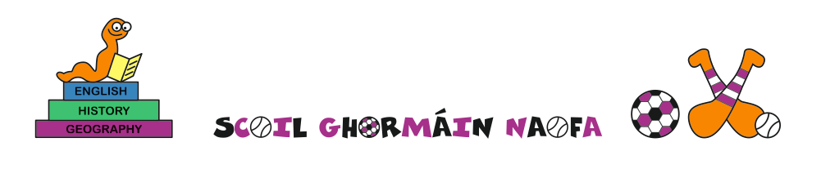
30/09/2020

Dear Parents and Staff

Re: If we have a confirmed case of COVID-19 in the school

We do not have any confirmed positive cases of Covid-19 in the school. However, it is only prudent that we consider what procedures are in place to deal with such a situation were it to arise, so that all of us are aware in advance of what happens in such an event.

Safety and Control Measures
The BoM, school leadership and staff are very conscious of the paramount need to keep all pupils, staff and visitors safe while in the school. The school is a controlled environment. There are control measures in place to combat the introduction or spread of COVID-19. These are based on:

- Physical Distancing
- Hand Hygiene
- Respiratory and Hygiene Etiquette
- Mask Wearing, where necessary.

When a person displays symptoms of COVID-19
The following steps are taken when a person (child or adult) in the school presents with suspected COVID-19 symptoms:

- In the case of children their parents will be asked to come to the school, take them home and contact their GP for a free telephone consultation
- If the GP recommends that the person (child or adult) go for a COVID-19 test, that person is now considered a query case for COVID-19 and all of his/her household members must restrict their movements until the results of the test come back
- In the case of a negative result (98% of cases), the GP will advise when the person should return to school – usually after 48 hours.
- In the case of a positive result (2% of cases), Public Health will, by law, be informed. This may take a matter of hours due to legal and volume of work issues. The risk has been removed from the school as the person who tested positive and his/her household are at home
- The person tested, or their parents, may well be informed before Public Health. In many cases a social media discussion ensues and anxiety levels are raised among the school community.

Public Health Intervention
The Public Health Department of the HSE is the agency responsible by law for dealing with positive cases of COVID-19:

- Once notified by the HSE testing regime, Public Health Doctors assume total control of the situation and will carry out a risk assessment. Based on questioning the person with the positive result, they will ascertain if they were within the school setting when they contracted the virus. If not, there may be no need to contact the school
- If the person was within the school setting when they contracted the virus, Public Health will contact the principal to carry out a Public Health Risk Assessment. This is a set of questions to see who might have been exposed to the virus and who needs to be excluded or tested. This risk assessment will be unique to each school
- The principal and BoM have no function in the risk assessment, other than to provide whatever information is required by the Public Health Medical Officer conducting the risk assessment
- The principal and BoM may be asked to assist the Medical Office by sending a message from them to the relevant families identified in the risk assessment. Public Health will not contact other members of the school community
- The principal and BoM are not permitted to inform members of the school community of the identity of the person or persons who have tested positive for COVID-19 for the following reasons:

  - Doctor – Patient confidentiality
  - GDPR legislation prevents the publication of personal data without consent

Emer Russell
(Principal/Secretary Board of Management)

Scoil Ghormáin Naofa, Castletown, Gorey, Co. Wexford
Roll no. 17768k
Tel: 0402 37596
Email: secretarycastletownns@gmail.com

