Celebrating Water Heritage Day
Digital photo and reflections competition
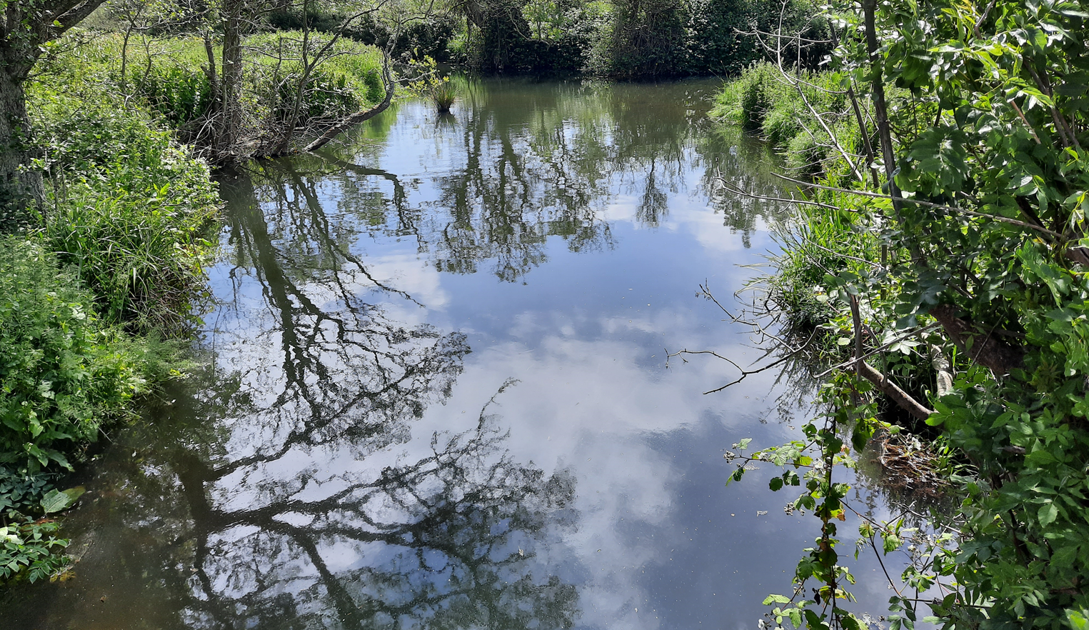
Ahare River and Estuary, County Wexford
To celebrate Water Heritage Day, the Friends of the Ahare River are holding a photographic and reflections competition focusing all cameras and smart phones on the wonderful Ahare River, which flows through North County Wexford. This fantastic family friendly competition runs for the duration of Heritage Week (August 15th to 23rd) 2020.
You are invited to submit a photograph with a reflection capturing your thoughts on the Ahare or Inch River. Photographs can feature anything associated with the Natural or Cultural Heritage of the Ahare River – examples could be wildlife photos taken from the Ahare River, scenic views of the river and estuary or old historical photos. Reflections to accompany the photograph can range in length – anything from a sentence to a paragraph – so long as they capturing your thoughts of celebration of the Ahare river.
Prizes for winning entries include Nature Books and a special edition of the Stories from the Waterside publication.
This is a family friendly event – why not join in and enter for some fantastic prizes!!
Email your photo and reflection to: cathyleeahare@yahoo.co.uk
Closing date of competition: Sunday evening August 23rd (Water Heritage Day 2020). Supported by Local Authority Waters Programme.
A Heritage Note: According to George Henry Bassett in the About Wexford, Country Guide and Directory 1885 “The Parish of Inch is five miles English from Gorey, on the Inch and Owengorman river, which abounds in trout and salmon.” The Ahare River is also known as the Inch river.
Photos may be used to form a poster display celebrating the river or featured in the local press.

