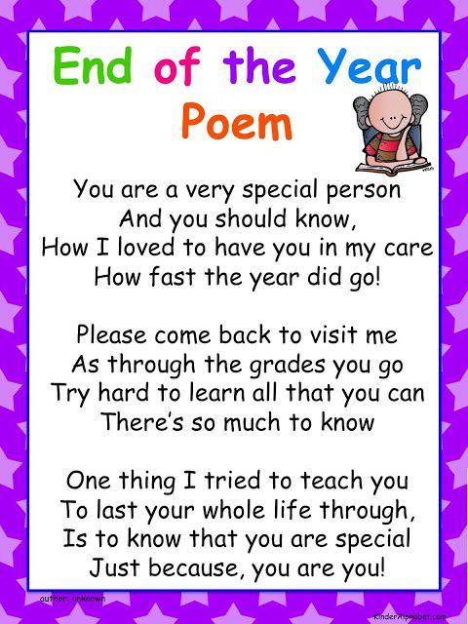

**Dates to Remember**

**August 28th 10-12.30;**

School Uniforms for sale in the school

**August 30th 9am;**

Students return to school

**Meet the Staff of 2018/2019**

**Ms. E. Russell:** Principal

**Ms. A Gilmartin Ryan:** Deputy Principal & S.E.T.

**Ms. L. Whittle:**  Junior & Senior Infants

**Ms. J. Murphy:**  1st/2nd Class

**To be appointed:**  3rd/4th Class teacher

**Mr. N. Breen:**4th/5th Class

**Ms. N. Byrne**: 6th Class

**To be appointed:** ASD class teacher

**Ms. M. McDevitt /Ms. P. D’Arcy**: S.E.T.

**Carmel Duke and Finola Quirke** are our S.N.A.s

**Siobhán** **Geoghan** is our Secretary

We will also be **appointing** a shared SET teacher and new S.N.A.s.

**School email address:** [**cns.iaswx@gmail.com**](mailto:cns.iaswx@gmail.com)



**School website address:** [**www.castletownnationalschool.ie**](http://www.castletownnationalschool.ie)

**School Twitter account:**

**@castletown_ns**

**Welcome note from the Principal…..**

It is hard to believe that a **full school year** has passed. We have redesigned the final newsletter of the year to summarise the great work and activities that went on in Scoil Ghormáin Naofa since September. It has been busy, it has been fun and I hope that **lasting happy memories** have been made for our students.

Next year, our staff have elected to pursue **STEM** (Science, Technology, Engineering and Maths) teaching as their area of **continuous professional development**. We have registered for training of staff in the area of STEM through the **Discovery Primary Science and Maths initiative**. We have also applied for staff development training through PDST (Professional Development Service for Teachers). We are really excited about building on our existing knowledge and sharing new methodologies with our students.

**SSE: School Self Evaluation:** Scoil Ghormáin Naofa is engaging with the SSE process and has selected **Physical Literacy** as its area for development. We are grateful to Ms. D’Arcy and Mr. Breen who are receiving professional development in the area and who will spearhead the initiative in school.

I am delighted to inform you that we will be offering a couple of **after school clubs** next year. The details are to be confirmed but they will offer an alternative option to sport which is already brilliantly facilitated within our school community.

We are looking forward to **welcoming our new students** next year, both to junior infants and into our ASD class (we will be renaming this class in September). We are sorry to say **farewell** to our 6th class students who have had such an exciting year with Ms. Byrne. We wish them every happiness and success in whichever field they choose.

For **continued learning over the summer**, students are encouraged to avail of the library reading challenge. I have enclosed leaflets with the reports. Continuation of reading good quality material is very important. We encourage parents to **foster the love of reading** in their children by establishing mini book clubs with friends or simply by reading to their children over the summer. I recently sent home booklets from [www.helpmykidlearn.ie](http://www.helpmykidlearn.ie) which has many ideas on how to make learning fun over the summer holidays.

**First Holy Communion** was a really special day for our 2nd class students and I commend them on how respectfully they conducted themselves in church on the day. They carried out their jobs with pride. I am **very grateful** to Ms Murphy, Carmel, Ms. McDevitt, Ms Byrne, Finola, Siobhan and importantly, the priests of the parish, who were all involved in making the occasion so special.

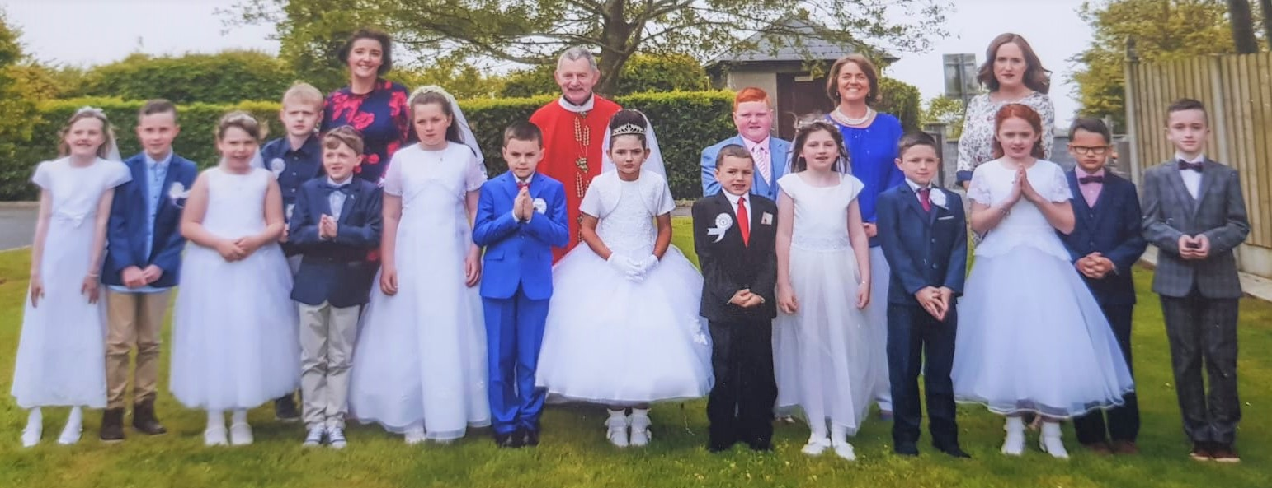

I wish to thank the members of the **board of management** for their time and support in running the school. It is entirely voluntary and we are grateful to have a board who so genuinely want to promote our school. Likewise to our **Parents’ Association**, many thanks for all the fundraising, interest in our school and activities that you have provided over the year. We wish **Rochella Kinsella** all the best as she steps down from her office as Chairperson, she will be greatly missed. I wish to thank our teachers, secretary, SNAs and parents who coached/facilitated events for all that they have given of themselves over the year. Each person has contributed greatly to the life of the school. There is a great **vibrancy** in school and this is down to the **enthusiasm** of staff which has a knock on effect on our students.

I wish you all a **happy summer**, full of fun and hopefully sun!

Emer Russell

Principal

**Welcome to our**

**Newsletter!**

**Summer 2018**



**‘Scoil Ghormáin Naofa’ Newsletter**

**Castletown, Inch, Gorey, Co. Wexford**

**0402-37596**

**email:**[cns.iaswx@gmail.com](mailto:cns.iaswex@gmail.com)



**June 20th**

**School Tour**

**School Opening Hours**

School opening hours are 9 a.m. -2.40 p.m. A reminder to parents that official school supervision begins at 8.50 a.m. We would appreciate your support in relation to this.

**Curriculum News**

**Maths Week**

|  |  |
| --- | --- |
| ***Q. What do mathematicians eat on Halloween?***  ***A. Pumpkin Pi.***  **https://lh5.googleusercontent.com/vE565grBz55nvxupqDSV5Z-QZmt9pWbpYt_IA1kYnc8=w735-h583-no** |  |

Maths week was celebrated in Scoil Ghormáin Naofa from 13th - 17th October. During this week we all made a special effort to mark the occasion; going on maths trails, playing maths games and holding quizzes. We also used this week to launch our School Self-Evaluation process for Numeracy. To date we have a received a great response to our online survey and we are looking forward to collating the results after midterm. For anyone who would still like to complete the survey the link is:  <http://tinyurl.com/castletownns>

|  |  |
| --- | --- |
| **Fire Safety Week**  ***Theme for 2014: Working Smoke Alarms Save Lives*** |  |

As part of Fire Safety Week (October 5th -11th) we held a fire drill in conjunction with Gorey Fire Station. Two fire engines and crews visited the school and participated in a rescue operation. Thankfully Ms. McDevitt, Gearóid and Aoife were all found safe and sound! There was great excitement seeing the fire brigades, hoses and firemen. We also had a great feature in the local paper ‘The Gorey Guardian’.

|  |  |
| --- | --- |
| **Mental Health Awareness Week**  ***‘Singing is good for the soul!’*** |  |

As part of Mental Health Awareness week (5th - 12th October) we attended ‘The Big Sing’ in the Arklow Bay Hotel alongside other primary and secondary schools in the locality. Scoil Ghormáin Naofa was proudly represented by 1st to 6th classes. We sang a lovely medley by combining the three songs, ‘Our Community Song’, ‘You’ve Got a Friend’ and ’I’ll be There for You’.  It was a great day out for all involved as we enjoyed performing and also listening to the other school’s compositions. What a great way to promote Mental Health Awareness for both children and adults!

**Paired Reading**

Paired reading is currently taking place from Infants to 2nd class. It is proving to be a very enjoyable and beneficial experience for both parents and children alike. Thank you to all parents who are helping out!

**Calling all Historians Young and Old**

Things are still moving forward with our Local History Initiative and we would still welcome all members of the community to submit photographs, articles etc.

|  |  |
| --- | --- |
| **Active School Week 2018:** | http://www.darverns.ie/wp-content/uploads/2016/03/Active-School-Flag.jpg |

Active School Week ran from the 14th to 18th of May. Wow, what an ACTIVE week it was! Each morning, except for Thursday, we kick started the day with **Wake Up Shake Up.** Our first morning began with Ms.McDevitt as she got us all moving and grooving to **Zumba**. On Tuesday, 5th class showed us all how to do the **Floss dance**. On Wednesday we were put through our paces by Jenny from **Fitness 4 You**. A lot of us had sore leg muscles after this one, but it was super! Thanks to **Aideen O’ Shaughnessy** for arranging this one. On Friday morning Mr. Breen, with the help of Fiona, laid out a **staggering 18 circuits**; which most certainly got us awake and shaking! Huge thanks to you all.

Also on Monday, Cathy O’Toole from the **National Tug of War Association** gave 3rd /4th class a lesson in the rules of tug of war and the best strategies to use to achieve maximum results. Tug of War competitions took place daily after lunch for all classes. This activity is always thoroughly enjoyed by all.

**Penalty shootout** took place every lunch time; all classes participated in this. Thanks to 6th class and Ms.Byrne for running this activity so successfully over the week. The final was played on sports day. Mr. Breen was in goal for the hurling and Anthony Masterson was in goal for the football. The Football winner was **Emer Ivanoff** and the hurling winner was **Conor Fanning**. Anthony also did a sports day penalty shoot-out from 3rd -6th class and **Dylan Bealin** won this. Huge **thanks to Anthony** for giving up his time to be with us.

Another daily activity enjoyed by all, was **athletics** with our SNA Fiona. All classes received a masterclass in athletics. The junior classes learned the fundamentals of running through some fun games which focused on agility, balance and co-ordination. They were also introduced to good running posture, arm swing and foot landing. The senior classes not only focused on running but practised some jumping and throwing activities. The javelin proved to be very popular and we witnessed lots of very impressive throws. Thank you Fiona, perhaps we have **future Olympians** in our midst.

An **Active Walkway** was set up around the school. It is signposted and available for all classes to use at their discretion any time of the year (weather permitting). The classes can walk around in pairs saying their tables, asking each other spellings, saying the alphabet, counting, asking each other to name the counties in each province, say a poem, sing a song etc.… but all the while getting **fresh air, exercise and keeping them alert** while doing so.

On Wednesday we were paid a visit by **local celebrity**, the wonderful **Mary Hickey**, thanks to Ms.Russell for organising. The pupils learned about the 65 year old’s **Lap of the Map**. They listened as she told them of her challenging, eventful and arduous run around the coast of Ireland for the RNLI. That’s a 5000km run!!! Mary is no novice to impressive feats of endurance, she is also the only woman to have completed every single Dublin Marathon, (all 38 of them!). She’s also completed the gruelling **Marathon des Sables** in the Sahara Desert, known as the ‘toughest footrace on earth’, has won the Wicklow Way Ultra, and run several city marathons including London and Boston. Well done Mary, you are super woman!!!

Thursday was our most Active and fun day. The **Parents’ Association** along with the **Active crew** organised a super challenge and fund raiser for the whole school community. We all braved **Croghan Mountain** and came back smiling. The children, while exercising, got plenty of the freshest of air, learned about **wind power** and had fun outside the classroom whilst raising money for the school. We had a **picnic** and returned to school for more activities. We are so thankful to the Parents’ Association, the parents for the lifts and everyone who made this possible.

Back at school after lunch we held our Mini World Cup finals. This league had been running every Thursday at lunch times during term 2 with the help of 6th class. **Pete O’ Brien**, Kalina’s dad in infants, bravely refereed (thanks Pete!). Scotland and Wales played in the girls’ final. **Scotland was victorious** and the team consisted of Sophie Ivanoff (captain), Louise Foley, Kadie McAuliffe, Isobel O’ Flaherty and Freya Molloy with Sofia Church as sub on the day.

Portugal and Brazil played in the boys’ final. Portugal was victorious and the team consisted of Ross Higgins (captain), Fionn Kavanagh, Mikey Kinsella, Jordan Murphy, Tadgh Shelley and Aaron Halford. Thanks so much to **Rochella Kinsella** and **Concepta Church** who laid out an array of **beautiful fruit** on the day for us all.

Then it was time for the **annual basketball game**; teachers and parents vs 6th class. What a game it was too!!! What 6th class lacked in height they made up for in determination, strength and pure desire to beat the opposition. It was tough, dirty and emotional at times! But the adults narrowly won in the end. **Mí-ádh rang a sé!**

Friday was our last day of Active school week and again it was so busy. We had Rackard league matches, the 3rd game that week for the girls!!! We had another special visitor to our school, **Yvonne Doyle**, who by trade was a **professional tennis player.** She represented Ireland on the world stage for several years. For us however she led **mindfulness sessions** with each class. It was a lovely way to calmly ease down after our busy week. She was wonderful!!! Afterwards she spoke to classes 3rd-6th about her **tennis career** which was fascinating. Huge thanks to Yvonne for this lovely treat for the children.

Then finally to complete our active week we had **Walk a Mile (1.6km) with a Smile** before we went home to rest.

Huge thank you to Ms.Russell and all the teachers and SNAs for their support, enthusiasm and participation all week, without them all the above is not possible. Thanks to the parents, the visitors and anyone else who helped in anyway big or small.

Ms D’Arcy and the Active School Committee.

|  |  |  |
| --- | --- | --- |
| C:\Users\shaugax\Desktop\n11.JPG  **Donal Power and his wonderful**  **Wildlife Presentation** | C:\Users\shaugax\Desktop\n9.jpg  **Enjoying our ice-creams on the beach – thank you Ms. Byrne** | C:\Users\shaugax\Desktop\n14.jpg  **Walk with a Smile** |

**Science, Technology, Engineering and Technology**

**STEM** has made its way to Castletown! Over the last year, the teachers and students of Scoil Ghormáin Naofa embraced STEM and recognised its importance in educating our pupils for the future. Our annual Science Week and Maths Week events took place once again and the school took part in Engineers’ Week for the first year.

**Maths Week** was a huge success and the whole school got involved! Children completed a **maths problem** a day and Ms. Kinsella organised a **maths trail** for the older children. Junior and Senior Infants took part in a **shape hunt**. For the second year running the **Maths Eyes competition** took place. This year was an even bigger success than last year! There were plenty of mathematical photos on display with interesting questions and witty slogans too.

As part of **Science Week**, the children were busy completing experiments in their classes. These experiments were showcased during our **Science Fair** for the whole school community to see. It was lovely to see so many parents attend and a few even took part! The **Big Bear Planetarium** came to visit just after our Science Week fun had passed. The children loved this experience and got a closer look at what wonders Space holds. The inquisitive children of our school came away with lots of questions and an eagerness to search for answers.

And finally, our school celebrated its first **Engineers’ Week**. Children discussed the job of engineers and took part in **Bricks for Kidz** workshop. In the workshop, each child built cars with working motors. This workshop was enjoyed by all levels and the school will look at continuing this success into the future.

**Louise Whittle**

**Reading Recovery**

We are privileged and delighted to have the hugely successful **Reading Recovery** programme available in our school. Reading Recovery is a very **effective early intervention programme** which has great outcomes for the children involved. It is designed for children from the age of 5.9 in junior infants and senior infants who are taken each day for 30 minutes on a **one-to-one basis** by a trained Reading Recovery teacher. The programme ensures that each child has access to the **best possible learning outcomes** and they are helped to reach their full potential. The programme provides intensive individual support for children in both reading and writing whereby they usually make rapid progress and become **independent readers** by the time they complete the programme. It can only be provided to about four children at a time and lasts about 20 weeks. **Parents are involved** in supporting the programme and they are delighted with the outcome for their children. One parent reported that ‘it is brilliant, I can’t believe the difference it has made to my child’. Children who have participated in the programme have really enjoyed it as have I.

**Anne Gilmartin-Ryan**

**Green School Update**

Well what an exciting term for our **Green School Committee**; Jack Kenny, Katie Kinsella, Conor Fanning,Aaron Halford, Erin Cunningham, Harry Ryan, David Byrne and Niall O’Shaughnessy. All your hard work paid off!! They collected their **green flag** in Kilkenny on the 22nd of May. Two lucky people, Erin Cunningham and Conor Fanning, were picked from a hat to have the very important job of going to the **award ceremony** and getting presented with the flag. Our **bug hotel** is work in progress, our **garden** looks fantastic thanks to Carmel! Our **wildflower area** got off to an unfortunate start but is well on its way now and we had a lovely visit from **Donal Power** with his amazing photographs of wildlife around us.

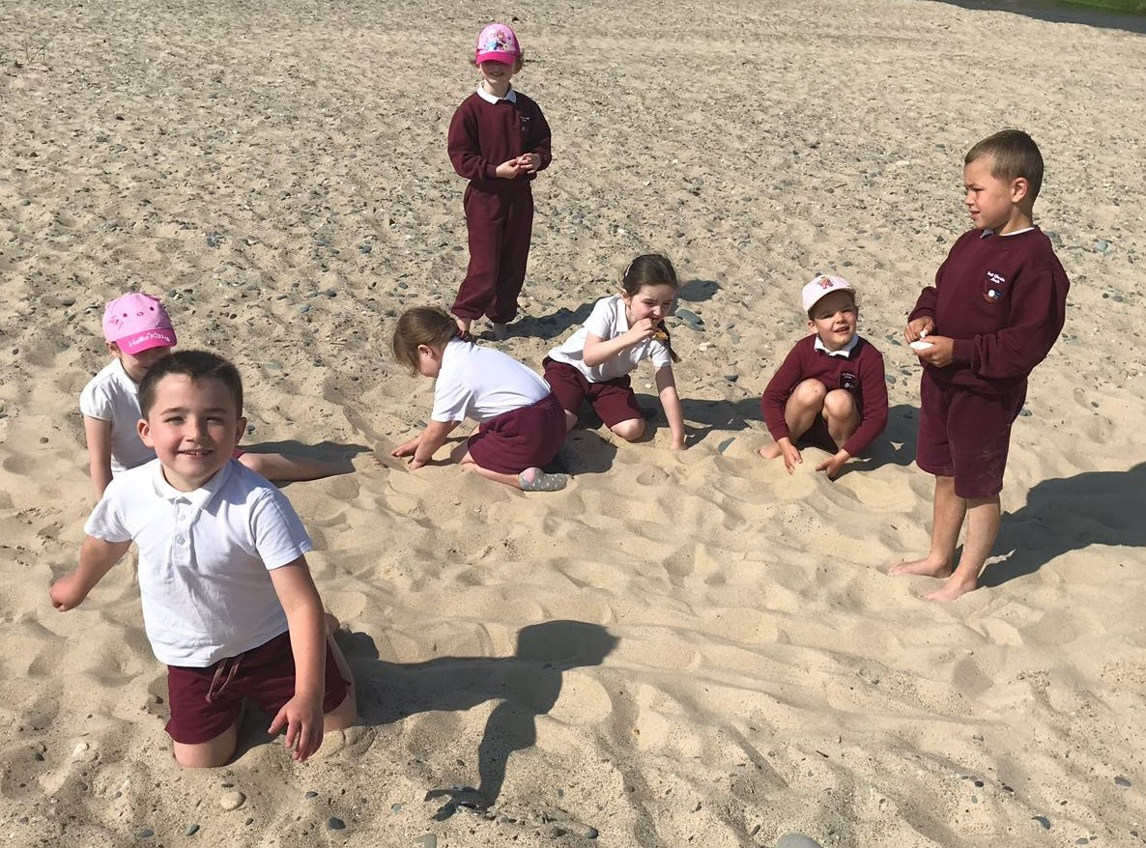 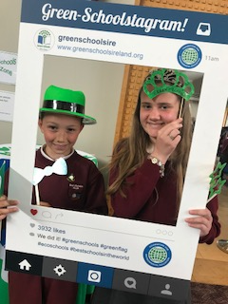

As the weather wasn’t on our side previously, we carried out our **“action day”** last week with our very successful trip to **Clone beach**. With fantastic weather and a very informative Julie Robertson who has a keen interest in biodiversity, we had a great day. We learned a lot about the **marine ecosystem** and looked at various items we gathered along the beach. All the classes were excellently behaved and it is always a **proud moment** when a visitor to our school mentions how well behaved all children are and also how **enthusiastic** they are towards listening and learning - so well done all!  We are now on the road to our **Global Citizenship flag** focusing

on litter. This will be a learning curve for us all but looking back now, how many of us knew what Biodiversity meant 2 years ago??!! So onwards and upwards to our **next challenge**!

**Maresa McDevitt**

**GAA**

**Boys’ Mini 7s and Rackard League**

It is hard to believe that the year is coming to an end. The **busy schedule** of the Mini 7s and Rackard League certainly kept us all on our toes. Let’s have quick look back at what the boys achieved throughout the school year! All the way back in September the school started their **GAA journey** with the Mini 7s football tournament in Castletown. The team won their way through three blitzes to get to the final. They then faced Rathangan in the final on a cold and wet evening in November; however the weather was not going to faze the **determined Castletown panel** as the boys came out on top with a convincing win to **make history** for the school by winning the competition for the first time!!

The Rackard League football team also had a great run with a good mix of players from Castletown, Coolgreaney and Tara Hill. The team had some **fantastic performances** along the way with wins over Bunclody, Ferns, Kilmuckridge and Castlebridge. Yet again Castletown made the **semi-final in division A** where we played a very strong Piercestown team who went on to claim the county title. The boys put up a great fight against Piercestown but just fell short by a few points.

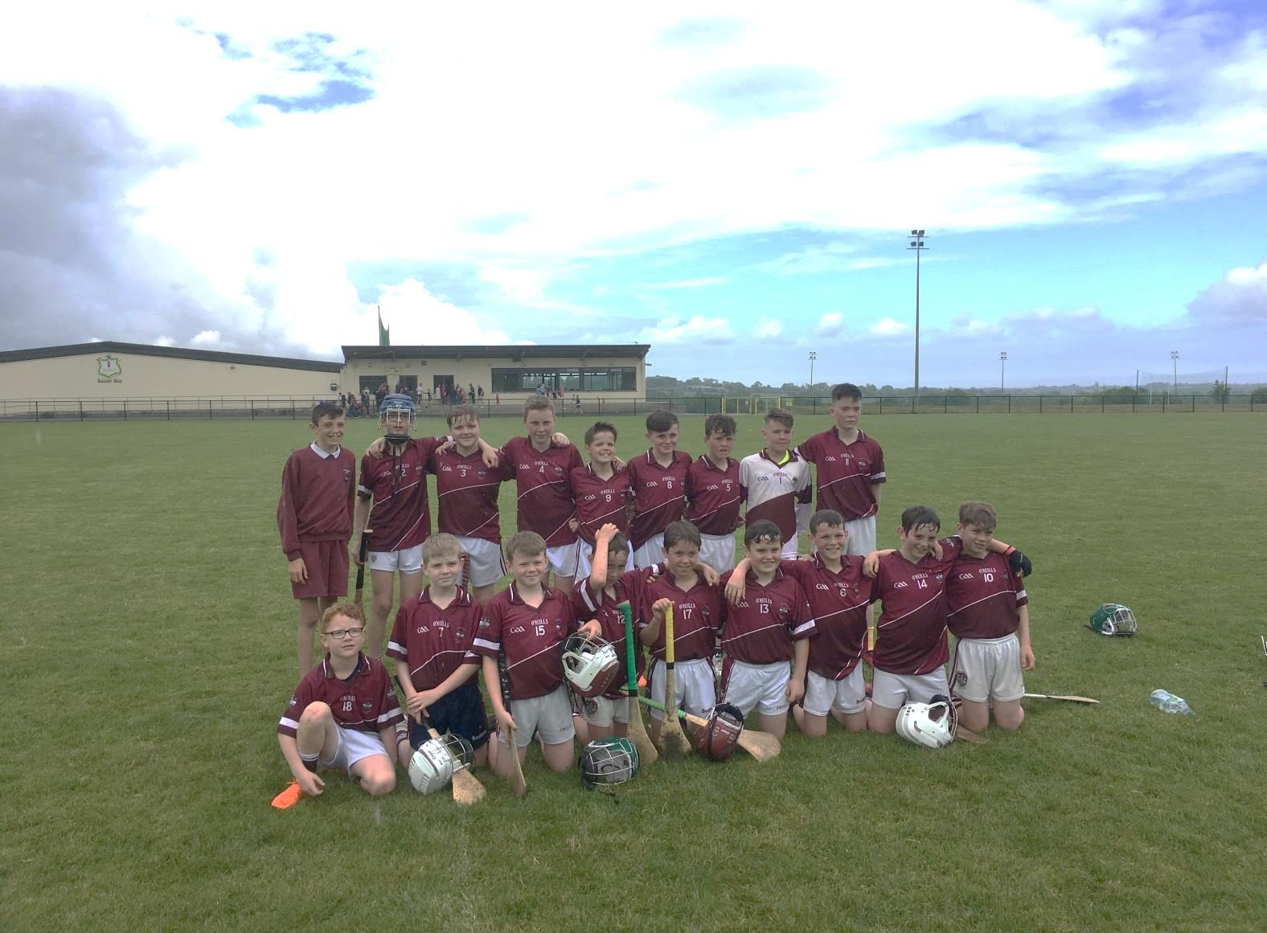

The **7s hurling,** which kicked off in term 2, also proved to be very eventful as the team reached the **semi-final stage** which was played in Monageer on a very warm afternoon. We were on the losing side to a strong Rathnure side in a game that went to extra time twice to try and find a winner. The boys showed great heart throughout and fought to the very end. The boys also had a great run in the **Rackard League hurling** as they again created history by reaching the **A quarter final** against Oulart with wins over Kilmuckridge, Craanford and Gorey along the way.

Outside of the Rackard League and mini 7s there was lots happening in the GAA circle with the **Tríona Byrne Memorial Cup**, our own **hurling blitz** for 4th to 6th class players, the 3rd and 4th class hurling blitz in the Chris Murray Arena, the **school super blitzes** at the **Ferns Centre of Excellence**, **external GAA coaches** for hurling and football and finally the **school club link with Anthony Masterson**. It is important to us to offer a mix of **competitive and non-competitive** options.

3rd

**Arklow Music Festival 2018**

Due to the snow, the postponed **Arklow Music and Drama festival** eventually went ahead after the Easter holidays. It is the norm that teachers, if they so choose, take part in the class action/choral verse competitions as they give children an opportunity to **perform in public in a safe and secure environment** surrounded by their peers. Each child has a voice and gains confidence from such an experience. It is not about winning but the participation, teamwork, public speaking skills, listening skills, poetry and acting skills gained from being involved. However, it was yet again another extremely successful year for Scoil Ghormáin Naofa.

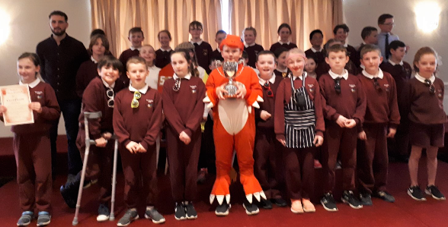

Mr.Breen’s class assisted by Ms.D’Arcy came 1st with ‘The Dragon Who Ate Our School.’

Ms.Murphy’s class was Very Highly Commended or 3rd with ‘The Salmon of Knowledge.’

Ms.Russell’s class came 2nd with ‘Macavity, the Mystery Cat.’

Ms.Byrne’s class came 2nd with Roald Dahl’s ‘The Three Little Pigs.’

Ms.D’Arcy’s drama students, Siofra Higgins and Louise Foley received Very Highly Commended in the Duologue Drama, Sofia Church won the monologue drama and there were many individual awards for solo verse speaking also.

An awful lot of **hard work** is put into these performances so well done to all involved and thanks to our prop and costume lady; Carmel Duke. Thanks also to Johnny Byrne for the 6th class set design.

**Paula D’Arcy**

**Junior Entrepreneur**

A big **well done** to the boys and girls of 6th class who went to the RDS on Monday 18th June for the **Junior Entrepreneur National Showcase Day**. 480 schools completed this project and 140 schools were chosen to go forward to the national competition.

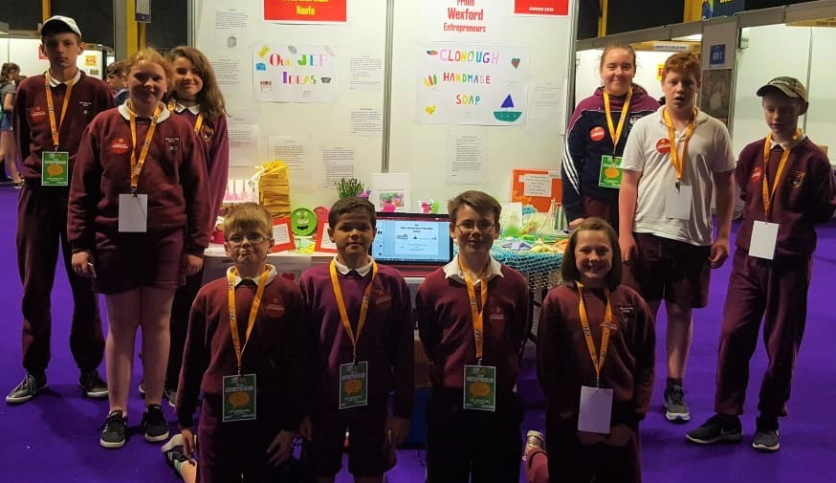

We were very **proud** to achieve this and we were shortlisted for the most **creative project** on the day. The class raised over €1400 and kindly donated €400 to charity. The **Jack and Jill Foundation and LauraLynn charity** were both very grateful for this and it is nice to make a difference to these very deserving causes. Thank you to everybody who supported us on our journey.

**Nicky Byrne**

**Parent’s Association Update**

We have had a **busy year** of events supported by the Parents’ Association including the Hallowe’en Disco, The Big Bear Planetarium, Dance Workshop, Christmas Cards, Grandparents’ Day, Pancake Day, Easter Bunny, Communion Teas, Paired Reading and Welcome Teas to name a few. The **Croghan Walk** fundraiser was a huge success with both parents and children - thank you to Ms D’Arcy and Siobhan who put in a lot of work to make it happen.  A sincere thank you to the parents who donated their time and helped to make **Sports Day** such a great day, it was great to have new helpers on the day, We were delighted to end the school year on a high, and we wish our sixth class students the very best of luck moving on to secondary school. On a **personal note** I am stepping aside as Chairperson, although I will continue as part of the committee. I feel very **proud** of all that we have accomplished and have no doubt that this will continue.  I would like to thank you for the **opportunity** to be able to work to provide all the extra benefits the children were afforded through the support of the P.A.  It has been a pleasure to have been Chairperson for the last three years.

**Rochella Kinsella**

**GAA cont’d.**

Overall it was a very positive and successful year for GAA in Scoil Ghormain Naofa. We would like to thank all the children who took part in GAA throughout the year. They all **represented their school** excellently and as always with pride. A huge thank you to all **parents** for your **ongoing support** and for providing lifts to all games which are always very much appreciated. A **special thanks to Mick Kavanagh** for all his help with the teams, training and for having the jerseys clean and ready for every game. Finally, thanks to Ms. Russell and all the staff for their support and organisation for games and training. Let’s all hope next year brings us as much **joy on the playing fields.**

**Niall Breen**

**Girls Mini 7s/Rackard League Camogie 2018**

The girls got off to a **good start** with the **Mini 7s Camogie** competition earlier in the year, beating Kilanerin and qualifying for the second round. This was a great **boost for the girls** and it was fantastic to welcome our fourth class Camogie players on board. Unfortunately, we lost out in the second round to Loreto and Ballyroebuck and did not progress any further in the competition.

The **Rackard League** competition proved challenging for our girls this year as we came up against some very strong teams. Having said that, it was great for the girls to be **back with their club mates** for these matches and they **supported each other** very well. We came away with a draw on our first day out against Ballygarrett and the girls showed great skill and determination for this match. Next we went on to play Monageer at home and were **thrilled** to have won this match after getting some great scores and defending so well in the backs. Unfortunately, our winning ways began and ended here as a very strong Loreto team came to Castletown soon after and proved the better team on the day. Our last game of the year was played in Coolgreany against old rivals Kilanerin and unfortunately, after a very tiring active week in school and having played club matches over the week, the girls lost out to their neighbours.

The girls from all three schools showed **great team spirit** and **enthusiasm** towards Camogie this year and their **desire to represent their school in such a positive way** was extremely admirable. Hopefully next year will bring us more luck but the girls should take pride in how they performed in each test over both competitions. **Baile an Chaisleain abu!**

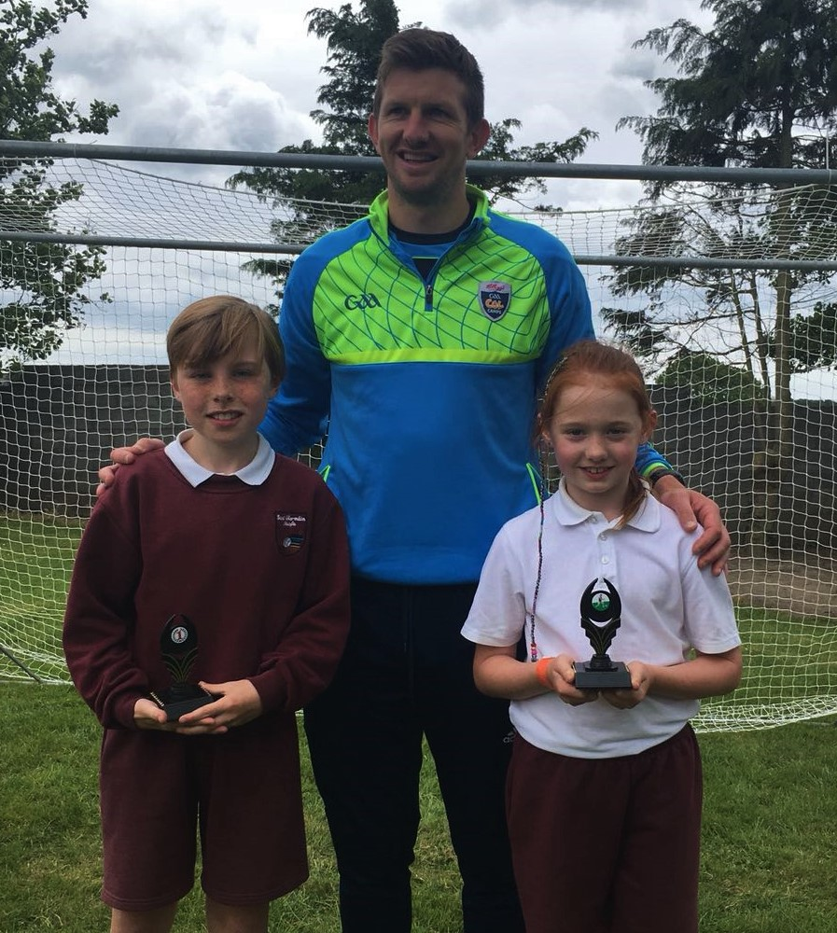

**Sports Day Fun; Dylan Bealin, Anthony Masterson & Emer Ivanoff**